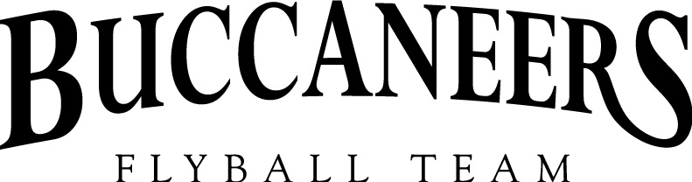
Invite you to a
BFA LIMITED OPEN SANCTIONED TOURNAMENT
(Limited 48 teams)
on the 11th and 12th June 2022
Closing date for entries 13th May 2022
To be held at
Diana Brimblecombe Animal Rescue Centre
Nelsons Lane, Hurst, Nr. Wokingham, Berkshire,
RG10 0RR
Please Note: NO entries can be accepted without payment.
Electronic entries accepted.
Camping is available from 2pm on Friday 10th June

For further information contact:
Katie Robinson
44 Merino Road, The Atrium, Andover, Hampshire SP11 6SP
Mobile: 07769290206
Email: kitty-kat128@hotmail.com

Buccaneers Limited Open Sanctioned Flyball Tournament
(48 teams) 11th and 12th June 2022
Closing date for entries 11th May 2022
Team Name/s | BFA Number
1.
2.
3.
4.
5.
6.
Qualified Judges Available:

Provisional Judges Available: | Measuring Judges Available:

Declared times must be submitted in writing (or email) at least 14 days before the tournament and must be at least half a second faster or slower than seed time (4.4)
Team break out time is half a second faster than declared time (A.3 (11))
All times, seed or declared, except Division 1, are subject to the Division break-out rule.

Team Captain: | Address:
Telephone: | Address:
Email: | Address:

Team Entry @ £45 per team |  |  | £
Camping @ £8.00 per Unit per Night | Friday | Saturday
Number of Units per Night |  |  | £
Total made payable to: BARJO BUCCANEERS  Payment by BACS to: BARJO BUCCANEERS  Sort Code: 30-93-32  Account Number: 02589304  Please use team name as reference |  |  | £

Please complete and return to: Katie Robinson, 44 Merino Road, The Atrium, Andover, Hampshire, SP11 6SP
Online entries accepted – email: kitty-kat128@hotmail.com

Show Rules and Regulations
- Event organiser(s) reserve the right to refuse entries and admission to the event of any persons not in good standing with the BFA.
- No person shall carry out punitive or harsh handling of a dog at the event.
- Bitches in season are not allowed near the show area.
- Mating of dogs is not allowed.
- A dog must be withdrawn from competition if it is:
Suffering from infectious or contagious diseases.
A danger to the safety of any person or animal.
Likely to cause suffering to the dog if it continues to compete.
- It is the Team Captains responsibility to ensure the team is available for their division and running order.
- The organiser(s) reserve the right to make any alterations they deem necessary in the event of unforeseen circumstances.
- All dogs are entered in the event at their owners risk and whilst every care will be taken, the event organiser(s) cannot accept responsibility for damage injury or loss, however caused, to dog’s, persons or property whilst at the event.
- No alcohol can be consumed within the ring.
- Smoking including vaping/electronic cigarettes is not permitted in or within 15 feet of the flyball ring during competitions and presentation.
- All owners/handlers must clean up after their dogs. Anyone failing to do so, will be asked to leave the venue.
- BFA rules and policies will apply throughout the sanctioned tournament.
- If circumstances make it necessary for a tournament to be cancelled, the organiser(s) reserve the right to defray expenses incurred by deducting such expenses from the entry fees received.
- There will be “zero” tolerance of abusive or foul language inside the ring to either ring party, judges and other team members.

Requests for specific days
We will try to accommodate teams who request specific days however, this cannot be guaranteed.
The running order cannot be considered until two weeks prior to the event at the earliest due to the seed list update and therefore it is impossible to guarantee any request until that time whether successful or not. Refunds will not be issued if we are unable to accommodate your request and you withdraw beyond the competition closing date.

