

present a


Sanctioned Competition

Limited Open Flyball Tournament (54 Teams)
at
Camperdown Country Park, Dundee, Scotland, DD2 4TF

20th & 21st July 2019
(Closing date 20th June 2019)

Featuring: Limited Open Classes (Block Format) and Starters
Camping available on site for Friday & Saturday night

Paper entries to: Alan Wood, 9 The Logan, Liff, Dundee, Angus, DD2 5PJ
Email entries to: awood@taysideroadrunners.co.uk

Contact Alan Wood: Phone: 01382 580443 / 07968210975
Email: awood@taysideroadrunners.co.uk



Entry Form for BFA sanctioned Limited Open Tournament (54 Teams)
Camperdown Country Park, Dundee
20th & 21st July 2019
(Closing date for entries is 20th June 2019)
Entry Fee £40 per team

Declared times must be submitted in writing or email at least 14 days before the tournament & must be at least one second slower than seed time (BFA Rule 4.5).
N.B. Team break out time is half a second faster than declared time (5.17(l)). Declared times faster than the seed time are not subject to the team break out rule. All times, seed or declared, except Div 1, are subject to the division break out rule.

 | Team Name | Team BFA Number
1
2
3
4
5
6
7

Team Captain:
Address:
Tel No:
Email:

Entries accepted via e-mail to awood@taysideroadrunners.co.uk

Alternatively, please complete and return forms and payment via post - See over for Starters Entry, Camping Booking and Financial Information.

Please include an email address for running orders, which will be sent to team captains approximately one week prior to the event.

Starters Entry Form
Camperdown Country Park, Dundee
20th & 21st July 2019
(Closing date for entries is 20th June 2019)
Entry Fee £25 per Starters Team

Starters Team Name
1
2
3
4

Financial Information & Camping Booking

Number of Open Teams entered | _______ | @ £40 per team | = £
Number of Starter Teams entered | _______ | @ £25 per team | = £
Number of Camping Pitches (Friday) | _______ | @ £8 per pitch | = £
Number of Camping Pitches (Saturday) | _______ | @ £8 per pitch | = £
 |  | TOTAL | = £

Please return completed forms along with payment (cheque) to:
Alan Wood, 9 The Logan, Liff, Dundee, Angus, DD2 5PJ.

Or email entries to awood@taysideroadrunners.co.uk and bank details will be provided

Cheques enclosed for £_________ (payable to Alan Wood)
Email address for tournament info and running orders: ___________

Directions to Camperdown Country Park, Dundee, Scotland, DD2 4TF

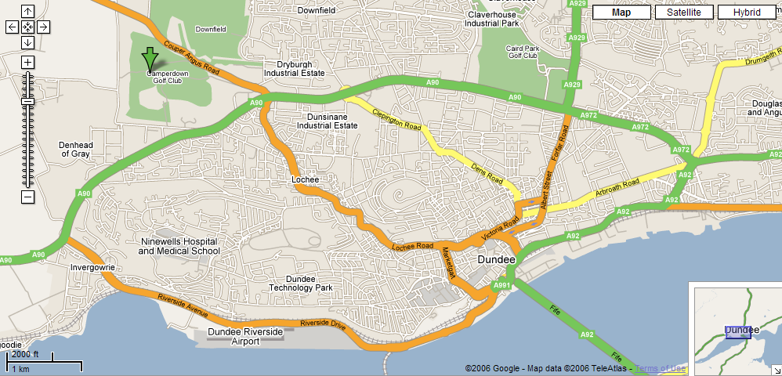
Reached by Dundee Outer Ring Road - Kingsway (A90). Take slip road for Coupar Angus Road (A923), then turn left into Camperdown Country Park.
Chewing the Fat catering van will be onsite over the weekend.
Nearby (walkable) fast food outlets available include KFC and McDonalds, as well as a Premier Inn with restaurant/bar. Tesco and Asda supermarkets are within a few minutes drive from the park.

Show Rules and Regulations

- The tournament organiser(s) reserve the right to refuse entries and admission to the event of any persons not in good standing with the B.F.A.
- No person shall carry out punitive or harsh handling of a dog at the event.
- Bitches in season are not allowed near the show area. Mating of dogs is not allowed.
- A dog must be withdrawn form competition if it is:
  - Suffering from infectious or contagious diseases.
  - A danger to the safety of any person or animal.
  - Likely to cause suffering to the dog if it continues to compete.
- It is the Team Captains responsibility to ensure the team is available in their class and running order.
- The organiser(s) reserve the right to make any alterations they deem necessary in the event of unforeseen circumstances
- All dogs enter the event at their own risk and whilst every care will be taken, the event organiser(s) cannot accept responsibility for damage, injury, or loss however caused to a dog’s, persons or property whilst at the event.
- All owners/handlers must clean up after their dogs. Anyone failing to do so will be asked to leave the venue.
- If circumstances make it necessary that the tournament in cancelled, the organisers reserve the right to defray expenses incurred by deducting such expenses from the entry fees received.
- B.F.A. rules and policies operative at the closing date for entries will be apply throughout the sanctioned tournament.

