NUNEATON FLYERS FLYBALL TEAMS

Invite you to a

British Flyball Association Sanctioned Limited Open Competition

at

Statfold Narrow Gauge Museum Trust, Ashby Road, Tamworth,

B79 0BU
on
2nd & 3rd July 2022

Entries limited to 54

Closing date 3rd June 2022

RR Staggered format outdoors.

Please note the main road through Statfold is a FOOTPATH/ BRIDLEWAY and will be used by members of the public as well as horses.

Show Rules and Regulations

- The Event Organiser(s) reserve the right to refuse entries and admission to the event of any persons, not in good standing within the BFA.

- No person shall carry out punitive or harsh handling of a dog at the event.

- Bitches in season are not allowed near the show area. Mating of dogs is not allowed.

- A dog must be withdrawn from the competition if it is:

- Suffering from infectious or contagious diseases.
- A danger to the safety of any person or animal.
- Likely to cause suffering to the dog if it continues to compete.

- It is the Team Captains’ responsibility to ensure the Team is available for their class and running order.
- No person shall impugn the decision of the head judge or judges.

- The organiser(s) reserve the right to make any alterations they deem necessary in the event of unforeseen circumstances.

- All dogs enter the event at their own risk and whilst every care will be taken, the Event Organiser(s) cannot accept responsibility for damage, injury, or loss however caused to dogs, persons or property whilst at the event.

- All owners/handlers must clear up after their dogs. Anyone failing to do so will be asked to leave the venue.

- If circumstances make it necessary to cancel the tournament the organisers reserve the right to defray expenses incurred by deducting such expenses from the entry fees received.

Current BFA Rules and Policies will apply throughout the Sanctioned Tournament.

Entry form for limited open competition
Statfold Museum Trust
2nd & 3rd July 2022
Declared times must be submitted in writing (or email) at least 14 days before the tournament as per BFA rules
All times, seed or declared, except Div 1, are subject to the Division break-out rule.

Team Name |  | Team Number
(1)
(2)
(3)
(4)
(5)
(6)
(7)
Team Captain Name- | Email address-  Contact number-

HJ’s & QJ’s available

Provisional judges available

Measuring officials available

Number of camping units @ £12 per night

Friday Saturday

Arrivals after 2 pm on Friday please, if you would like to come sooner, please contact us, this will enable us to organise the camping areas. Thank you.

Number of teams @ £50 each

Total payment- £

Please send postal entries & cheques to

Stuart Harrison
221 Watling Street
Grendon
Warkwicksire
CV9 2PJ

Email entries to nuneatonflyers@gmail.com

Cheques payable to Nuneaton Flyers Flyball Teams.
For bacs details and any enquiries please email as above

Enquiries via email only please



Statfold Narrow Gauge Museum Trust

- Campers to enter from the top gate (on the right-hand side as you enter Statfold) and travel down into the camping field.

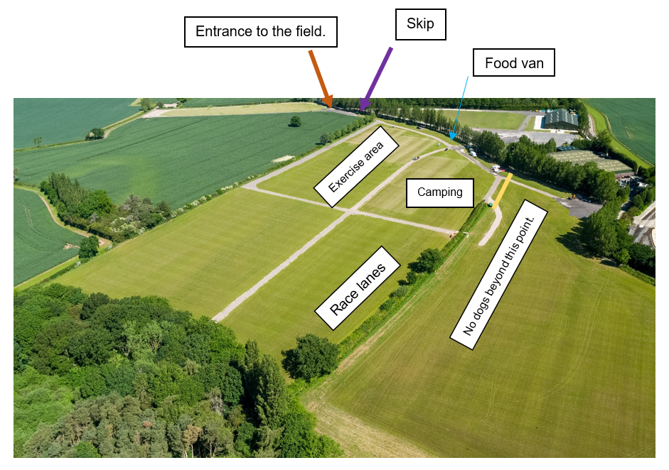

- Catering unit to be placed on the gravel by the green hut – tables and chairs can be provided for a small seating area. The catering van will be open from 8 am – 4 /5 pm. Food served will be-
  - Breakfast rolls (bacon, sausage, egg)
  - Lunch – Burgers, chips, hot dogs, jackets etc
  - Drinks – hot and cold.

- The play area is welcome to be used by the little ones, please note this is not in the field where camping and racing will be therefore it will be at your discretion.

- A skip will be placed at the top by the entrance you come in, but we will also place some drum bins in the field for waste, we also have yellow bins for dog waste too.

- There will be access available to the toilet and shower block.

- Water and elsan points are dotted around the field.

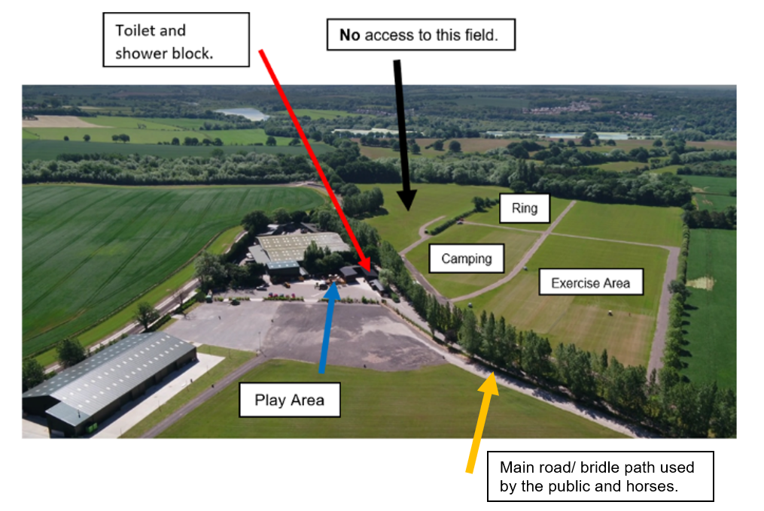
Directions to the show-
Get off at Junction 11 of M42
Take the exit B5493
Stay on this road for approximately 4.8 miles
The turning for Statfold will be on your left.

The nearest shops are-

Four Countries Spices- Indian takeaway
Ashby Road, No Man’s Heath Road, Tamworth
B79 0PB
Turn right as you exit Statfold
Approx. 4 miles away

The Co-operative-
29 Brooklime Way, Tamworth B79 0FD
Turn left as you exit Statfold
Approx. 2.1 miles away

Atlantic Fish Bar-
Atlantic Fish Bar Coton Green, The Precinct, Fontenaye Rd, Tamworth B79 8JT
Turn left as you exit Statfold
Approx. 3.7 miles away

Asda, Sainsbury’s KFC, Pets at Home, McDonalds, Petrol etc
Ventura Park road, Tamworth, B78 3HB

