
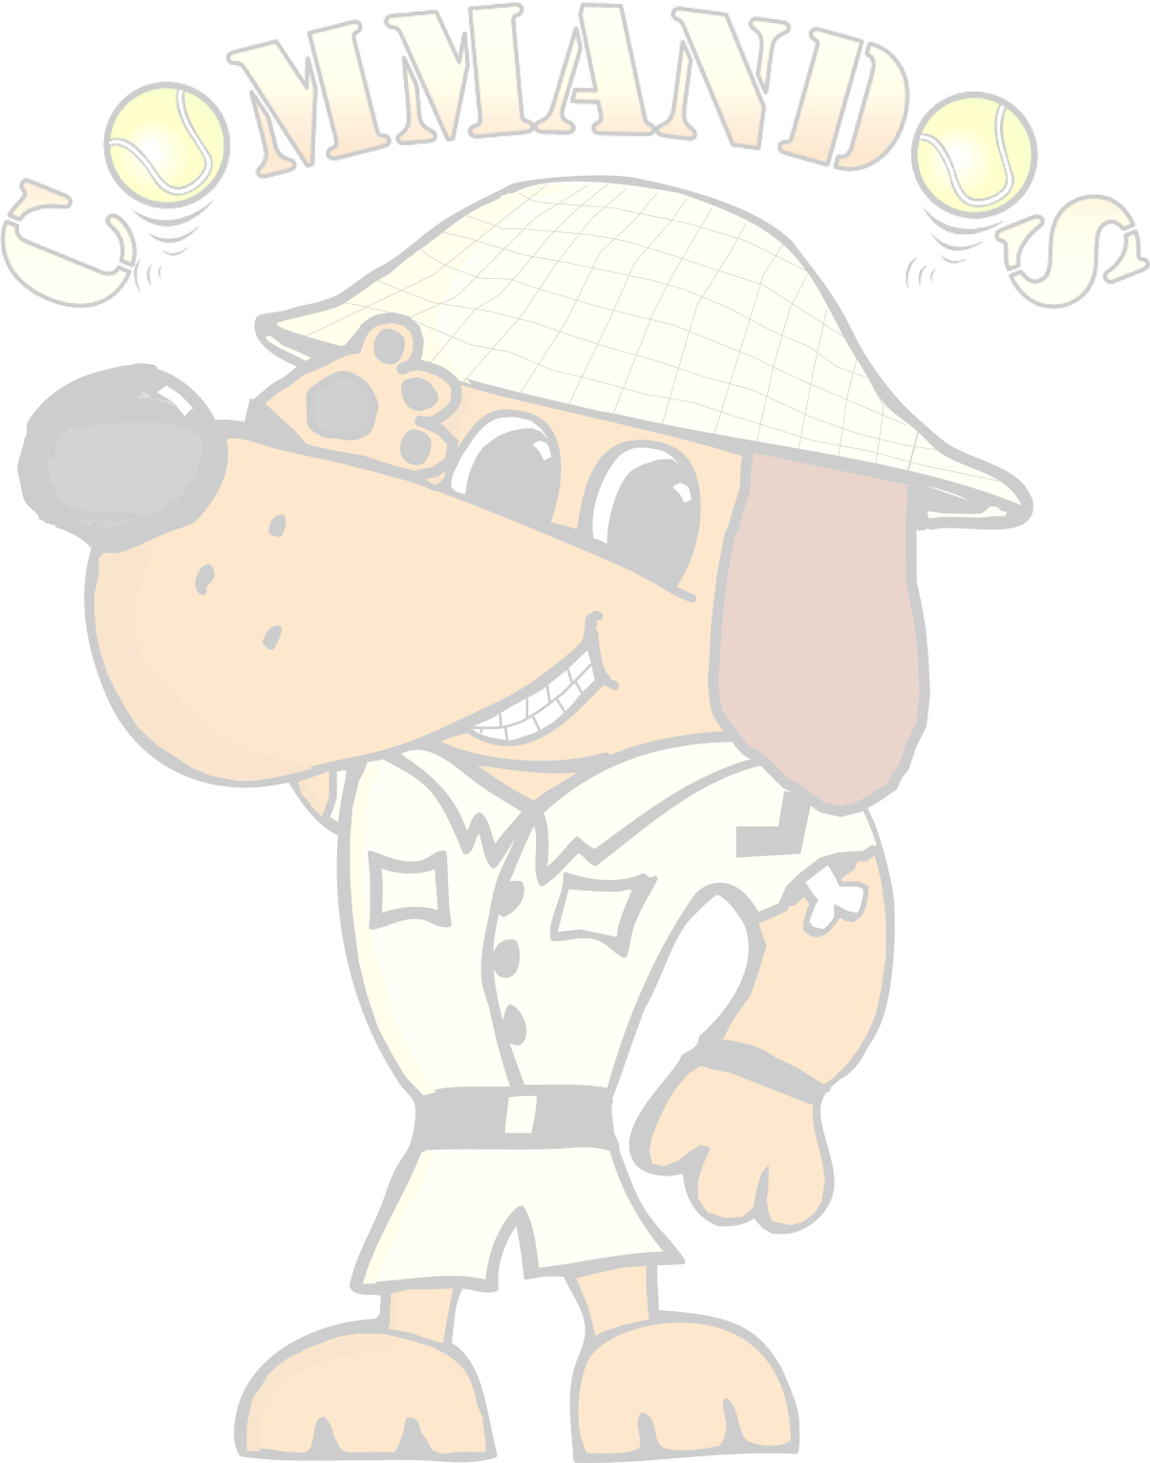
Flyball Teams
Present
Tootfest
British Flyball Association
Sanctioned Limited Open Tournament
54 teams- over 2 days
Starters Division Saturday only

to be held on 6th and 7th September
at

Hillside Rural Activities Park (HRAP) Oaktree Bank Knayton, Thirsk YO7 4AX

Closing date for entries:

8th August 2025
Event is block format held outdoors on grass over the full weekend

Starters Saturday Only (unsanctioned racing, not foundation)
- You will need 4 dogs to complete to receive a time for placing.
- Netting down centre of racing lanes & run-back area

Entries via google forms
https://forms.gle/obs9BwJsmqTYJ3959

Tournament Organiser
Josephine Walker
9 Hendren Close
Darlington
County Durham
DL3 0JD
Tel: 07496539335 E-mail: commandostournamententry@gmail.com

For your entry to be valid we require the Team Name, the TRN and the appropriate payment for each entry.

If we are oversubscribed at the 24-hour stage only valid entries will be included in the draw.
Payment either by cheque with entry or by bank transfer.
Cheques Payable to Commandos Flyball Teams.

Sort Code: 30-98-13
Account Number: 29698968

Declared times must be submitted, in writing or email at least 14 days before the tournament and must be at least ½ a second slower or ½ second faster than seed time. (BFA rule A1: 4.3)

Team Break Out Time is 0.25 of a second faster then declared time (BFA rule A3: 11)
All times, seed or declared, except Division 1, are subject to the division breakout rule.

Open teams and dogs must be able to run either Saturday or Sunday
£50 per open team

 | Team Name £50 per team | BFA Number
1
2
3
4
5

Starters Teams – Saturday only – (unsanctioned racing, not foundation)

 | Team Name £30 per team | Approx. time.
1
2

Team Captain:
Tel No
Email:

Please name any members wanting to judge or measure and if QJ, HJ, PJ PM



 | Camping Details
 | Fri & Sat Night Camping @ £25 …… units | £
 | Team entries
 | Open Teams ……… @ £50 per team | £
 | Starters Teams (Saturday Only)……… @ £30 per team | £
 | Total to pay | £

Directions

Hillside Rural Activities Park is close to the A19 trunk road, between the villages of Borrowby and Knayton, North Yorkshire (grid reference SE 42918 88091). The address is Oaktree Bank South, Knayton, Thirsk YO7 4AX.

Please note that Sat. Nav. directs on postcode YO7 4AL or YO7 4AN (from south)
Click Here to View In Google Maps

Tournament Rules and Regulations

Please note: Team Captains/Managers are responsible for ensuring that all members of their teams and accompanying party are informed of the rules and regulations pertaining to this tournament.

- The event organiser(s) reserve the right to refuse entries and admission to the event of any persons not in good standing within the BFA.

- No person shall carry out punitive or harsh handling of a dog at the event.

- Bitches in season are not allowed near the tournament area. Mating of dogs is not allowed.

- A dog must be withdrawn from competition if it is:
  - Suffering from infectious or contagious diseases.
  - A danger to the safety of any person or animal.
  - Likely to cause suffering to the dog if it continues to compete.

- It is the Team Captain’s responsibility to ensure the Team is available for their races.

- No person shall impugn the decision of the Head Judge(s) or Judges

- The organiser(s) reserve the right to make any alterations they deem necessary in the event of unforeseen circumstances.

- All dogs enter the event at their own risk and whilst every care will be taken, the Event Organiser (s) cannot accept responsibility for damage, injury or loss however caused to dogs, persons or property whilst at the event.

- All owners/handlers must clear up after their dogs and deposit waste in designated areas provided on site, to enable us to keep this venue for any further competitions. Anyone failing to do so will be asked to leave the venue.

- If circumstances make it necessary to cancel the tournament, the organisers
reserve the right to defray expenses incurred by deducting such expenses from the entry fees received

- BFA Rules and Policies operative at the closing date for entries will apply throughout the Sanctioned Tournament.

- All teams entering are expected to assist with Ring Party duties as requested by the Tournament Organiser

- No alcohol to be consumed within or around the ring

