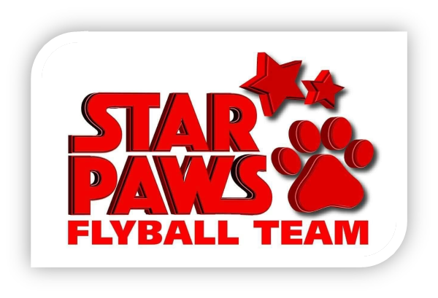

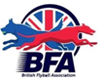
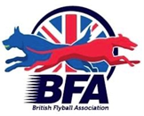

Star Paws Flyball Team

Present a British Flyball Association

OPEN SANCTIONED TOURNAMENT
&
Foundation
On Saturday 11th April 2026

Closing date for all entries Saturday 14th March 2026

To be held at: Errol Airfield, Morris Lelsie Hall, Errol, PH2 7TB

Racing will be Round Robin Block Format on Tuffspun

PLEASE NOTE: No entries can be accepted without payment

For further information contact Mandy Herald, starpawsflyball@outlook.com
6 Balcathie Farm Cottage, ARBROATH, DD11 2PD 07885256758



Star Paws Flyball Team

Entry Form

LIMITED OPEN SANCTIONED TOURNAMENT
at Errol Airfield, Morris Lelie Hall, Errol, PH2 7TB
On Saturday 11th April 2026
Closing date for entries Saturday 14th March 2026

Team Name/s | BFA Team Number
1
2
3
4
5

Declared times must be submitted in writing (or email) by Saturday 28th March 2026 and must be at least 0.25 faster or slower than seed time. Team break-out time is a quarter of a second faster than declared time. All times, seed or declared, except Div 1, are subject to the division break out rule.

FOUNDATION TOURNAMENT
Team Name/s | BFA Team Number
1
2
3
4

Team Captain
Name: | Address:
Captain BFA Number: | Address:
Telephone Number: | Address:
E-Mail address: | Address:

Judges
Judges availability (please tick appropriate box and supply name). | Provisional Judge | Qualified Judge | Head Judge | Measuring Official

Open Team Entry @ £60 per team |  | £
Foundation Team Entry @ £40 per team |  | £
Camping @ £10 per unit per night.  Camping Availability from Friday through to Monday. Showers and toilets available.  No hookup. | Number of units Friday | £
 | Number of units Saturday | £
 | Number of units Sunday | £
TOTAL PAYMENT |  | £

All Entries

Payment to Star Paws Flyball Team
Bank of Scotland Account number 17516867 Sort code 80-22-60

Complete and return to: Mandy Herald, 6 Balcathie Farm Cottage, ARBROATH, DD11 2PD, starpawsflyball@outlook.com. Final running orders will be sent out approximately 1 week before the tournament.

NO ENTRIES WILL BE ACCEPTED WITHOUT PAYMENT

Show Rules and Regulations

1. The tournament organiser(s) reserve the right to refuse entries and admission to any person not in good standing with the B.F.A.
2. B.F.A. rules and policies will apply throughout the sanctioned tournament.
3. No person shall carry out punitive or harsh handling of a dog at the tournament.
4. It is the Team Captains responsibility to ensure the Team is available for its class and running order.
5. The organiser(s) reserve the right to make any alterations they deem necessary in the event of unforeseen circumstances.
6. Bitches in season are not allowed near the show area. Mating of dogs is not allowed.
7. A dog must be withdrawn from competition if it is:
a. Suffering from any infectious or contagious disease
b. A danger to safety of any person or animal
c. Likely to cause suffering to the dog if it continues to compete
8. All dogs enter into the tournament at their own risk and whilst every care will be taken, the organiser(s) cannot accept responsibility for damage, injury or loss however caused to dogs, persons or property whilst at the event.
9. All owners/handlers must clean up after their dogs. Anyone failing to do so will be asked to leave the venue.
10. No alcohol is to be consumed within or around the ring.
11. If circumstances make it necessary that the tournament is cancelled, the organisers reserve the right to defray expenses incurred by deducting such expenses from entry fees received.
Please be aware of the following rules that apply to this venue
12. NO BARBEQUES TO BE USED DIRECTLY ON THE GRASS MUST BE OFF THE GROUND
13. CAMPING SITES WILL BE ALLOCATED AND MUST BE KEPT TO FOR FIRE REGULATIONS

