

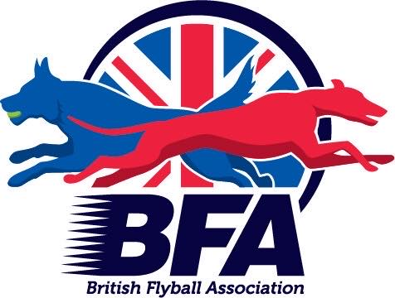
BFA Sanctioned
Flyball Tournament
&
Foundation
Sunday 2nd October 2022

Closing Date:16th August 2022

The Strand Building
Mitchelston Ind Est
Kirkcaldy
KY1 3LX

Indoor Tuff Spun

Entries to: Michelle Atkinson
92 Menteith Drive, Dunfermline Fife
KY11 8RS
Tel: 07522 922702
Email: matkinson694@googlemail.com

Show Rules and Regulations
- (1) The Event Organiser(s) reserve the right to refuse entries and admission to the event of any persons.
- (2) No person shall carry out punitive or harsh handling of a dog at the event.
- (3) Bitches in season are not allowed near the show area. Mating of dogs is not allowed.
- (4) A dog must be withdrawn from competition if it is:
- (a) Suffering from infectious or contagious diseases.
- (b) A danger to the safety of any person or animal.
- (c) Likely to cause suffering to the dog if it continues to compete.
- (5) It is the Teams Captain’s responsibility to ensure the team is available for their division and running order.
- (6) The organiser(s) reserve the right to make any alterations they deem
- necessary in the event of unforeseen circumstances.
- (7) All dogs enter the event at their own risk and whilst every care will be taken, the Event Organiser(s) cannot accept responsibility for damage, injury, or loss however caused to dogs, persons or property whilst at the event.
- (8) All owners/handlers must clear up after their dogs. Anyone failing to do so will be asked to leave the venue.
- (10) In the event of a 3 way tie winner will be decided on times. In a 2 way tie the winner is who beat who.
- (11)This is an INDOOR tournament, In the event of the tournament being cancelled, the organisers reserve the right to defray expenses incurred by deducting such expenses from the entry fees received
- THE TOURNAMENT WILL BE RUN ON
- TUFF SPUN MATTING
- Further information or queries please contact:
- Michelle Atkinson
- Tel: 07522 922702
- Email: matkinson694@googlemail.com

- Declared times should be submitted 14 days before the Tournament and must be at least 1/2 second faster or slower than seed time.
- Team break-out time is quarter of a second faster than declared time
- All times, seed or declared, except Div 1, are subject to the division break-out rule.
Open Teams
- TEAM NAME
- 1:
- 2:
- 3:
- 4:
- 5:
- 6:
Foundation Team names
(WILL ONLY BE RUN IF OPEN ENTRY IS NOT FULL)
1:
2:
3:
4:
Team Captain:
Address:
Telephone:
Email:

- Name of anyone who is a Head Judge, Qualified Judge, Provisional Judge, Qualified Measurer
or Provisional Measurer (HJ, QJ, PJ, QM, PM):

Number of teams entered.......................at £45.00 per team
Foundation teams @ £25.00
Total £...................
Payable to Carnegie Canines
Acc No: 11900764 Sort code: 80-22-60

