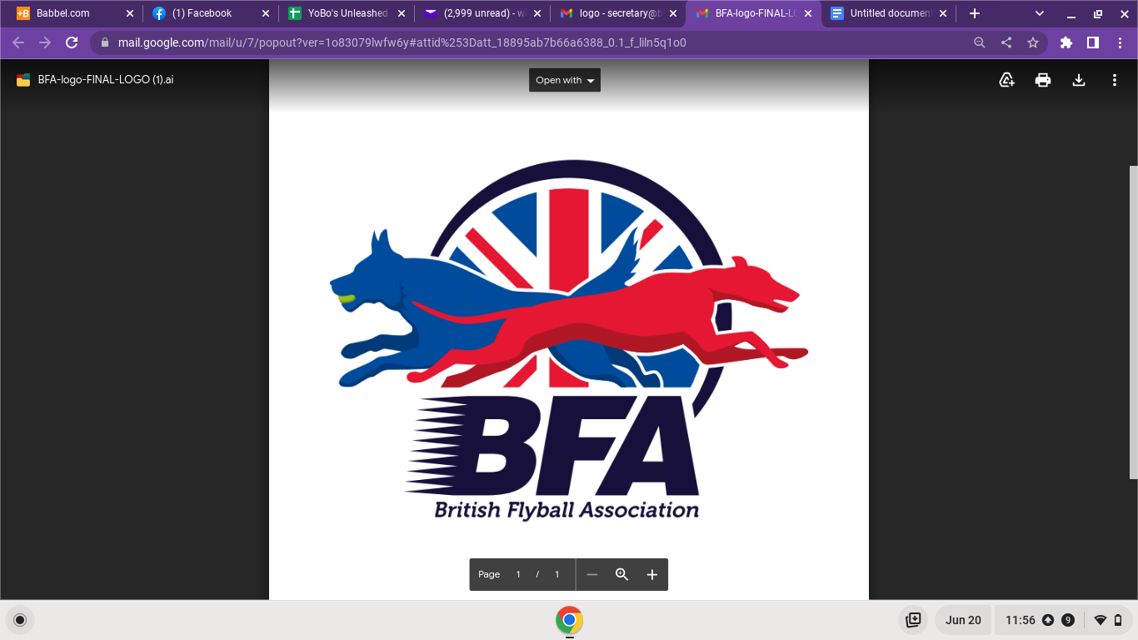

https://docs.google.com/forms/d/1RuA4_YCKETkweeSlCy6CVRoH1s4M-gKzTYK-cmf3yoM/edit?fbclid=IwAR2iEe4SE4es-fJkfMupdfcyAXSMrVwpcbF5f7KndXcxJ3jxqNfC2GOm7oQ

