
PRESENTS
A 96 TEAM BRITISH FLYBALL SANTIONED TOURNAMENT
AT
Mapledurham House
Reading
Berkshire
RG4 7TR
Saturday 7th & Sunday 8th July 2018
(Closing date for entries 1st June 2018)
For further information contact:
Erica Steele
Telephone: 07977 01 22 88
E-mail: wickedflyballclub@gmail.com
Postal address:
2 Marlborough Gardens
Oakley
Basingstoke
Hants
RG23 7AH
Online Entry
Please click on the link to enter using our online form
https://docs.google.com/forms/d/e/1FAIpQLSd_TFXmVPb6XRv6h2pYlIHRA2NfkobkEAgR-SGHg3w1wQCWOA/viewform?usp=sf_link

Winners prizes will be sponsored by Nutriment Raw Food


Entry form for limited open BFA sanctioned tournament
Saturday 7th and Sunday 8th July 2018
Declared times must be submitted in writing (or email) at least 14 days before the Tournament and must be at least a half second slower or faster than seed time.
(BFA rule 4.4)
Team Name | Team Number | Declared Y/N
1.
2.
3.
4.
5.
6.

Team Captain’s Name:
Team Captain’s BFA Number:
Address:

Telephone number:
Email:

Please could you provide names of people who would like to be judge, provisional judge or Height measurer
Judge
Provisional Judge
Height Measurer

Camping pitches required at £8 per night per pitch
Friday Night |  | £
Saturday Night |  | £
Total |  | £

Total payment £...………
Cheques payable to Wicked Flyball Club
Bank details sort code: 30-65-65 Account number: 50242868
Please put team name as reference (Entries will not be accepted without payment)
Starters
If we are able to provide a division of starters/Intermediates would you be interested in entering a team? YES/NO
Location how to find us
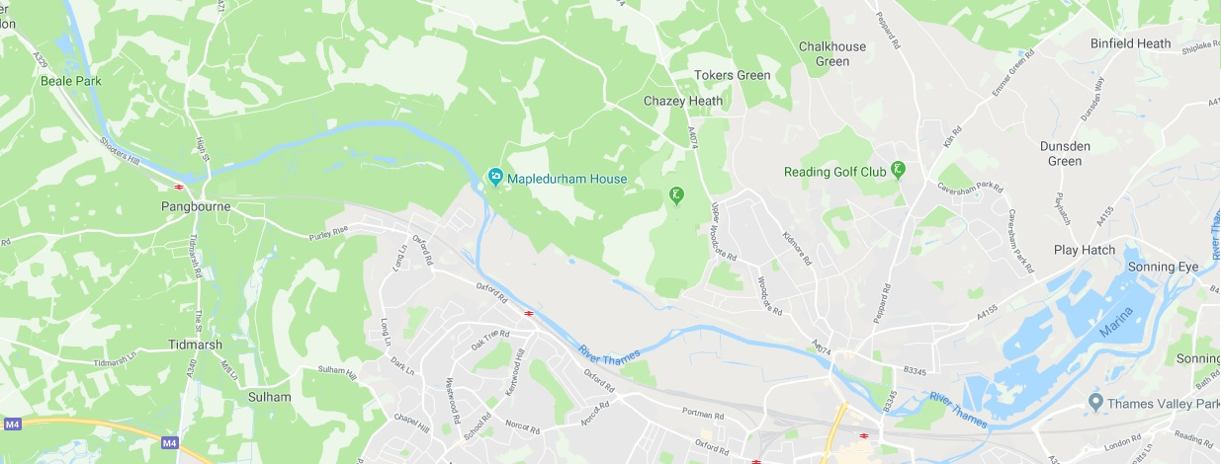
Refreshments
Delectable catering will be there over the whole weekend providing food and ice creams. We will be arranging a meal offer with them for the Saturday night closer the time.
Entertainment
Wicked will be providing entertainment on Saturday night in the marquee by the river, We would like to invite you to join us for a fun and relaxing evening.
Sponsors
Nutriment have kindly offered to sponsor our show and will be giving all our divisional winners and prize.
We look forward to seeing you in July
Wicked Flyball Club

Tournament Rules and Regulations
Requests for specific days
We will try to accommodate requests for specific days from teams, however this cannot be guaranteed. It is difficult to consider any requests until the running orders have been completed, 2 weeks prior to the event.
Sadly, refunds will not be issued if we are unable to accommodate your request and you withdraw beyond the competition closing date.
(1) The Event Organizer(s) reserve the right to refuse entries and admission to the event of any persons not in good standing within the BFA.
(2) No person shall carry out punitive or harsh handling of a dog at the event.
(3) Bitches in season are not allowed near the show area. Mating of dogs is not allowed.
(4) A dog must be withdrawn from competition if it is:
(a) Suffering from infectious or contagious diseases.
(b) A danger to the safety of any person or animal.
(c) Likely to cause suffering to the dog if it continues to compete.
(5) It is the Teams Captain’s responsibility to ensure the team is available for their division and running order.
(6) The organizer(s) reserve the right to make any alterations they deem necessary in the event of unforeseen circumstances.
(7) All dogs enter the event at their own risk and whilst every care will be taken, the Event Organizer(s) cannot accept responsibility for damage, injury, or loss however caused to dogs, persons or property whilst at the event.
(8) All owners/handlers must clear up after their dogs. Anyone failing to do so will be asked to leave the venue.
(9) Current BFA Rules and Policies will apply throughout the Sanctioned Tournament
(10) If circumstances make it necessary to cancel the tournament, the organisers reserve the right to defray expenses incurred
Please be aware of the following rules that apply to this venue;
(11) All competitors MUST obey any “out of bounds” or restricted areas that are in place.
No ground level BBQs are allowed

(12) All competitors and visitors are responsible for their dogs and must make every effort to ensure they do not cause noise nuisance when not racing (or waiting to race) to the equestrian centre surrounding the venue and visitors to Mapledurham Estate.

IT IS THE TEAM CAPTAINS RESPONSIBILITY TO ENSURE ALL MEMBERS OF THEIR TEAMS ARE AWARE OF THE RULES AND REGULAGTIONS FOR THIS SANCTIONED TOURNAMENT.

