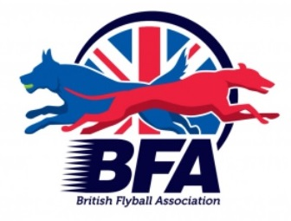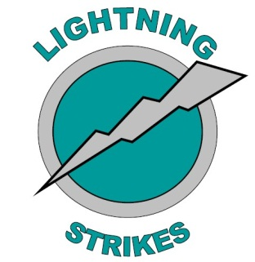

LIGHTNING STRIKES FLYBALL TEAM
PRESENT THEIR 10TH ANNIVERSARY
BRITISH FLYBALL ASSOCIATION
LIMITED OPEN COMPETITION

Hedsor Golf Club
Broad Lane, Wooburn Common, Bucks, HP10 0JW

On 29th & 30th June 2019 - CLOSING DATE: 29th May 2019
LIMITED OPEN TO 54 TEAMS - HEAD JUDGE: JASON BAKER

CONTACT: KIM SERMON – 07771 812862
*******EMAIL ENTRIES ARE ACCEPTED AT THE EMAIL ADDRESS BELOW. YOU WILL RECEIVE A CONFIRMATION OF ENTRY****** lightning_strikes@live.co.uk

Golf – 9 hole pay & play available over the weekend
Please keep dogs off the Golf Course!
Camping available from 12:00 on Friday.
Camping is limited and must be booked in advance. Camping will be marked out, and a plan will be issued.

There is a small club house with a small bar and snacks. Under 18s must be accompanied by an adult at all times.

There will be hampers for Divisional Winners. A big thank you for all the donations to these hampers.




ENTRY FORM - Limited Open – Saturday/Sunday

Declared times must be submitted in writing (or email) at least 14 days before the
tournament and must be at least half a second faster or slower than seed time (Rule
4.4). Team break out time is half a second faster than declared time (5.17(I)). All
times, seed or declared with the exception of Division One, are subject to the
Division breakout rule

Team Name Team Number
(1)
........................................................................ ...............................
(2)
........................................................................ ...............................
(3)
......................................................................... ................................
(4)
......................................................................... ................................
(5)
......................................................................... ................................
(6)
......................................................................... ................................

Team Captain: ........................................................................................

Telephone: ........................................................................................

E-Mail: ........................................................................................

Teams entered ............ at £40.00 per Team = £ .................

Qualified Judges: Provisional Judges:
_________________________________________________________________________________

Camping (£10.00 per unit per night).

Please book and pay for in advance as camping pitches will be marked out. Late bookings may not be able to be accommodated.

Friday……….. Saturday……….

Summary:
Open Teams: £........................
Starters Teams: £…………………….
Camping: £........................
TOTAL: £.........................
Cheques payable to Lightning Strikes Flyball Team
Please post entry forms to: Kim Sermon, Downwood, Kingswood Road, Penn, Bucks, HP10 8JL

Show Regulations:
- Current BFA Rules and Policies apply throughout the Sanctioned Tournament.
- The event organisers reserve the right to refuse entries and admission to the event of any person not in good standing within the BFA.
- No person shall carry out punitive or harsh handling of any dog.
- Bitches in season are not allowed near the tournament area.
- Mating of dogs is not allowed.
- Any bitch due to whelp within 7 days of the competitions is not permitted at the tournament.
- No bitch can compete whilst in pup and for at least eight weeks after giving birth.
- A dog must be withdrawn from the competition if it is suffering from an infectious or contagious disease, is a danger to the safety of any person or animal or if it is likely to cause suffering to the dog if it continues to compete.
- It is the Team Captain’s responsibility to ensure their team is available for their division.
- The organiser along with the Head Judge reserves the right to make necessary alterations in the event of unforeseen circumstances.
- If circumstances make it necessary to cancel the tournament, the organisers have the right to defray expenses incurred by deducting such expenses from the entry fees received.
- All dogs enter the event at their own risk. Every care will be taken to ensure the safety of the dogs and competitors but the tournament organiser cannot accept responsibility for damage, injury or loss caused to dogs or persons at the event.
- Competitors must pick up after their dogs. Anyone failing to do so will be asked to leave the venue.
- A two way tie will be decided by who beat who, a three way tie will be decided on fastest time.

Camping Regulations:
- Camping is limited, please be considerate when setting up.
- A bucket of water or fire extinguisher should be provided at each unit.
- All vehicles should keep to 5mph on the venue. Please keep driving during the tournament to a minimum.
- Please ensure generators are switched off between 11pm and 7am.
- Barbeques are allowed but please take extra care and ensure there is a water bucket to hand.
- Please pick up dog waste and litter.

Catering:

Catering will be provided on by the Bagel Bus



