
Flyball Team

Present a


British Flyball Association Sanctioned

LIMITED OPEN TOURNAMENT
(48 Teams over 2 Days)

To be Held at

Gaston’s Farm, Shillinglee Road, Chiddlingfold, GU8 4SX

On

Saturday 4th August and Sunday 5th August 2018

(Closing date for entries: 4th July 2018)
Sponsored by

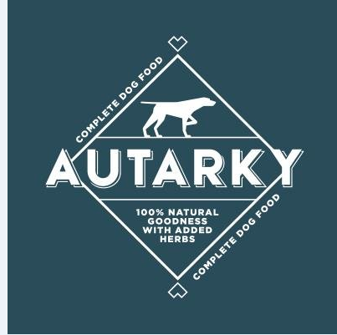

For further information please contact:

Wayne O'Rourke
Telephone: 02380 394 370
Mobile: 07902 738 230
E-mail: pawzitiffpawz@live.com
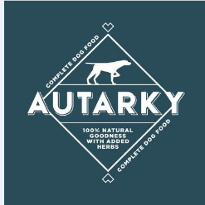

Tournament Rules and Regulations

- The Tournament Organiser(s) reserve the right to refuse entries and admission to the event of any persons not in good standing within the BFA.

- No person shall carry out punitive or harsh handling of a dog at the event.

- Bitches in season are not allowed near the tournament area. Mating of dogs is not allowed. Any bitch due to whelp within seven days of the competitions is not permitted at the Tournament. No bitch can compete whilst in pup and for at least eight weeks after giving birth.

- A dog must be withdrawn from competition if it is:
- Suffering from infectious or contagious diseases.
- A danger to the safety of any person or animal.
- Likely to cause suffering to the dog if it continues to compete.

- It is the Team Captain’s responsibility to ensure the Team is available for their Division and running order.

- The Organiser(s) reserve the right to make any alterations they deem necessary in the event of unforeseen circumstances.

- If circumstances make it necessary to cancel the Tournament, the Organiser(s) reserve the right to defray expenses incurred by deducting such expenses from the entry fees received.

- All dogs enter the event at their own risk and whilst every care will be taken, the Tournament Organiser(s) cannot accept responsibility for damage, injury, or loss however caused to dogs, persons or property whilst at the event.

- All owners/handlers must clear up after their dogs. Anyone failing to do so will be asked to leave the venue.

- Current BFA Rules and Policies will apply throughout the Sanctioned Tournament.

- No person shall impugn the decision of the head judge or judges.

Directions to Show Venue

The postcode for Gaston’s Farm is GU8 4SX.

Flyball Team

Entry Form for a BFA Sanctioned
Limited Open Tournament (48 Teams)

Saturday 4th August and Sunday 5th August 2018

(Closing date for entries: 4th July 2018)

Declared times must be submitted in writing (or by email) at least 14 days before the Tournament and must be at least ½ a second slower or faster than seed time (Rule 4.4)
All Declared Time’s are subject to a Team breakout time which is half a second faster than their declared time (Rule 5.17(l)).
All times, seed or declared, except Div 1, are subject to the division break-out rule.

 | Team Name | BFA Number
1
2
3
4
5
6

Team Captain Name: BFA Number:
Address:
Tel No:
e-mail:

Please List members willing to Judge or Measure and whether they are Provisional or Qualified:

Teams entered _______ at £40.00 per Team = £___________

Limited Open Tournaments
Camping and Team Entries.

Saturday 4th August and Sunday 5th August 2018

(Closing date for entries: 4th July 2018)

Camping is available on site for the nights of
Friday 3rd August and Saturday 4th August.
No arrivals before 12:00pm please.
No pre-booking is required, pay before departure/by team –
£8.00 per night per unit.

PLEASE NOTE:
ALL CAMPING FEES TO BE PAID AT THE SHOW AND NOT IN ADVANCE

All returns and enquiries to the Show Secretary:

Michael Blackman
43 Itchen Avenue
Bishopstoke
Eastleigh
Hampshire
SO50 8JW

Please make cheques payable to: Jets Flyball Team

E-mail entries and details for online payments to: michaelblackmanjets@gmail.com

Please provide an e-mail address or SAE for running orders.

