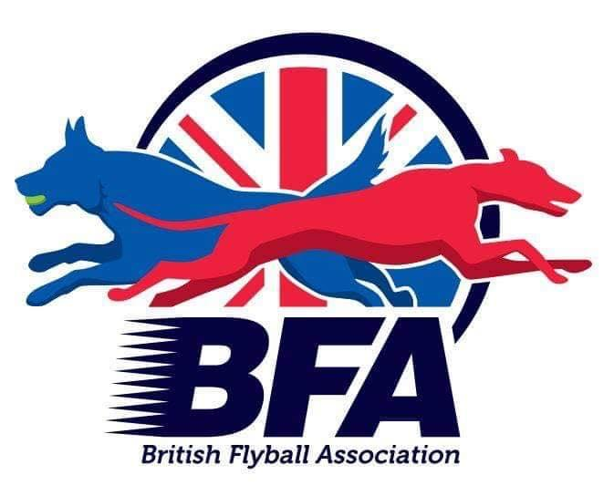
The British Flyball Association

Presents the
British Flyball Association
2023 INDOOR CHAMPIONSHIPS
LIMITED OPEN SANCTIONED TOURNAMENT (96 Teams)

13th to 15th October 2023
(Closing date for entries 12th September 2023)
To be held at
Newark Showground, NG24 2NY.

Electronic Entries (please note emailed entries will not be accepted):
https://forms.gle/T4QKoRxNs5eQ2krS9

Please send any queries to: secretary@bfa.email

Payment should be made via BACs to:

The British Flyball Association
Lloyds Bank
30-93-45
00417549

