Hoolinuns flyball competition
A BFA sanctioned, block format, limited open flyball tournament
(96 teams) Co-hosted by the Nuneaton Flyers and Hinckley Hooligans flyball teams
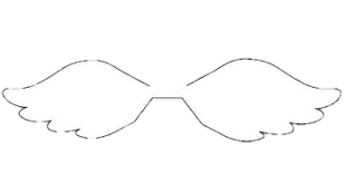



Newark Showground,
Lincoln Road,
Winthorpe,
Newark,
NG24 2NY

Closing date for entries; 5th May 2017
Accepting entries via www.iball4flyball.co.uk
Or email s.harrison6@ntlworld.com

Show Rules and Regulations

- The Event Organiser(s) reserve the right to refuse entries and admission to the event of any persons not in good standing within the BFA.

- No person shall carry out punitive or harsh handling of a dog at the event.

- Bitches in season are not allowed near the show area. Mating of dogs is not allowed.

- A dog must be withdrawn from competition if it is :

  - Suffering from infectious or contagious diseases.
  - A danger to the safety of any person or animal.
  - Likely to cause suffering to the dog if it continues to compete.

- It is the Team Captains responsibility to ensure the Team is available for their class and running order.
- No person shall impugn the decision of the head judge or judges.

- The organiser(s) reserve the right to make any alterations they deem necessary in the event of unforeseen circumstances.

- All dogs enter the event at their own risk and whilst every care will be taken, the Event Organiser(s) cannot accept responsibility for damage, injury, or loss however caused to dogs, persons or property whilst at the event.

- All owners/handlers must clear up after their dogs. Anyone failing to do so will be asked to leave the venue.

- If circumstances make it necessary to cancel the tournament the organisers reserve the right to defray expenses incurred by deducting such expenses from the entry fees received.

Current BFA Rules and Policies will apply throughout the Sanctioned Tournament.

Declared times must be submitted by email at least 14 days before the tournament and must be at least half a second faster or slower than seed time. (BFA rule 4.4) Team breakout time is half a second faster than declared time. All times, seed or declared, except Division 1, are subject to the division breakout rule. (BFA rule 5.17(I))

Team Name | Team Number
(1)
(2)
(3)
(4)
(5)
(6)
(7)
Team Captain Name and BFA number :
Telephone:
Email:
Teams entered __ ___ _ at £40.00 per Team = £___ _____

HJ’s & QJ’s available

Provisional judges available

Measuring officials available

Camping £7 per night
Camping | Number of caravans | Number of tents | Total units
Friday
Saturday

TOTAL £_____________

Bank details available on request. Cheques payable to Hinckley Hooligans Flyball teams.
All enquiries via email to s.harrison6@ntlworld.com

