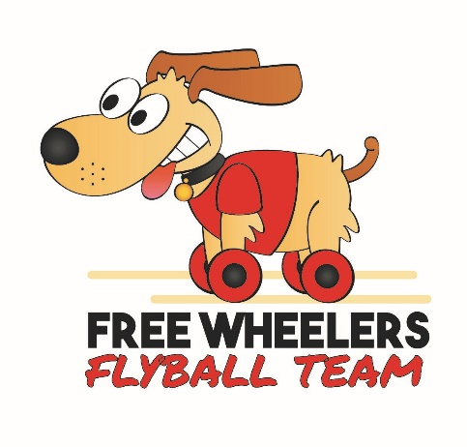



Free Wheelers Flyball Team, British Flyball Association
Sanctioned Limited Open
Tournament (48 Teams)
At The Breighton Ferry, Breighton, Selby YO8 6DH

On Saturday 22nd & Sunday 23rd June 2024
(closing date 25th May 2024}
Over 2 days

For more info please contact Ellie Wilson 07506 784369 or Claire Crowe 07793 504265

Please send entries to :
FreeWheelersTournaments@hotmail.com

Tournament Organiser – Ellie Wilson
Hedra Manor, 72 Main Road, Drax YO8 8NT

Entry form for limited open BFA sanctioned tournament.

Saturday 22nd and Sunday 23rd June 2024
Entry Fee £45 per Open Team
Foundation will be run if entries allow (£8 per dog, £32 max)

Declared times must be submitted in writing (or email) at least 14 days before the
Tournament and must be at least one half second faster or half a second slower than seed time. (BFA rule A1:4.3)
Team break-out time is 0.25 second faster than declared time (A3:11)
All times, seed or declared, except Div 1, are subject to the division break-out rule.

TEAM NAME | Open or Foundation | If open - TRN | £45
Total £
Team Captain’s name
Telephone
Address
Email

Camping spaces are limited on site - Camping @ £8per night

 |  | FRIDAY | SATURDAY | TOTAL £
 | No. of Caravans
 | No. of Motorhomes
No. of Tents
TOTAL£

Please name any members wanting to Judge or measure and if PJ, QJ, HJ, MO& PMO.

Payment either by cheque with entry or by bank transfer.
Cheques Payable to Freewheelers Flyball Club
Bank transfer, please use your team name as reference:-
Freewheelers Flyball Club
Account Number – 19775260 Sort Code – 77-71-61
Tournament Rules and Regulations

Please note: Team Captains are responsible for ensuring that all members of their teams and accompanying party are informed of the rules and regulations pertaining to this tournament.

1. The event organiser(s) reserve the right to refuse entries and admission to the event of any persons not in good standing within the BFA.
2. No person shall carry out punitive or harsh handling of a dog at the event.
3. Bitches in season are not allowed near the tournament area. Mating of dogs is not allowed.
4. A dog must be withdrawn from competition if it is:
a. Suffering from infectious or contagious diseases.
b. A danger to the safety of any person or animal.
c. Likely to cause suffering to the dog if it continues to compete.
5. It is the Team Captain’s responsibility to ensure the Team is available for their races.
6. No person shall impugn the decision of the Head Judge(s) or Judges
7. The organiser(s) reserve the right to make any alterations they deem necessary in the event of unforeseen circumstances.
8. All dogs enter the event at their own risk and whilst every care will be taken the Event Organiser (s) cannot accept responsibility for damage, injury or loss however caused to dogs, persons or property whilst at the event.
9. All owners/handlers must clear up after their dogs and deposit waste in designated areas provided on site, to enable us to keep this venue for any further competitions. Anyone failing to do so will be asked to leave the venue.
10. If circumstances make it necessary to cancel the tournament, the organisers.
reserve the right to defray expenses incurred by deducting such expenses from
the entry fees received .
11. BFA Rules and Policies operative at the closing date for entries will apply throughout the Sanctioned Tournament.
12. All teams entering are expected to assist with Ring Party duties as requested by the Tournament Organiser
13. No alcohol to be consumed within or around the ring

