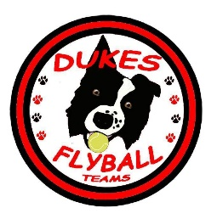 DUKES FLYBALL TEAMS 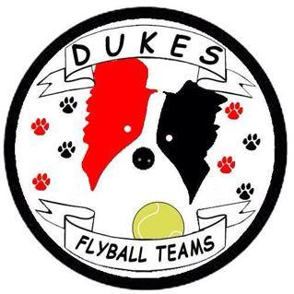
Present
A LIMITED OPEN TEAM TOURNAMENT
(Block RR format outdoors)
At
STOKE RUGBY CLUB,
Hartwell Lane, Stone
ST15 8TL
On
SATURDAY 14th & 15th JULY 2018
Closing date Friday 15th June 2018.

Featuring:
Limited Sanctioned Teams competition (max 48 teams).
Starters Teams Competition (Full netting).
If time fun events will take place.

There is a clubhouse on site with a bar, café, toilets and dog friendly.
Bins, Elsan Point and Water Tap available for campers. Changing rooms will be open overnight.
For further information please contact:
Paul and Sandra Walsh
Email: longtonflyball@gmail.com
Tel: 07966517173
Information
- This is a limited flyball competition (sanctioned by the BFA) with a maximum entry of 48 open teams. There will also be a starter’s competition (separate ring) and pairs/singles etc. may also be arranged in the same ring if time allows.
- Electronic entries will be accepted but not given precedence if arriving before the first post for postal entries. Entries must be received and paid for by the closing date then will be taken in strict order of receipt. Entries for the **Starters event must be made at the same time as for the Open competition. Each team will be treated as an individual entry [BFA rules 4.1 (g)].
- Any entries received after the closing date will only be accepted with an accompanying payment. This is providing spaces are available, otherwise these teams will be added to any reserve list.
- Camping is available at the price shown on the entry form. On site there is a clubhouse with toilets, bar and café. Those wishing to stay overnight please confirm on the form or a week before the date of the competition. The changing rooms will be left open overnight.

Show Rules and Regulations

(1) The Event organiser(s) reserve the right to refuse entries and admission to the event of any persons not in good standing with the BFA.
(2) No person shall carry out punitive or harsh handling of a dog at the event.
(3) Bitches in season are not allowed near the show area. Mating of dogs is not allowed.
(4) A dog must be withdrawn from competition if it is:
(a) Suffering from infectious or contagious diseases.
(b) A danger to the safety of any person or animal.
(c) Likely to cause suffering to the dog if it continues to compete.
(5) It is the Team Captains responsibility to ensure the Team is available for their class and running order.
(6) No person shall impugn the decision of the head judge or judges.
(7) The organiser(s) reserve the right to make any alterations they deem necessary in the event of unforeseen circumstances.
(8) All dogs enter the event at their own risk and whilst every care will be taken, the Event Organiser(s) cannot accept responsibility for damage, injury, or loss however caused to dogs, persons or property whilst at the event.
(9) No alcohol can be consumed within or around the ring.
(10) All owners/handlers must clean up after their dog. Anyone failing to do so will be asked to leave the venue.
(11) If circumstances make it necessary that the tournament is cancelled, the organisers reserve the right to defray expenses incurred by deducting such expenses from entry fees received.
(12) On and around the Rugby Club grounds a strict speed limit (5 mph) will apply.
(13) Current BFA Rules and Policies, at the closing date for entries, will apply throughout the Sanctioned Tournament.

DUKES FLYBALL TEAMS
Limited Open Sanctioned Competition – 14th & 15th July 2018
STOKE RUGBY CLUB, HARTWELL LANE, STONE ST15 8TL

OPEN TEAM NAME |  |  |  | TRN
(1)
(2)
(3)
(4)
(5)
(6)
STARTERS TEAM NAME |  |  |  | ESTIMATED TIME
(1)
(2)
TEAM CAPTAIN:
ADDRESS:
TELEPHONE: |  | EMAIL:
Electronic entries will be accepted via email, but no entry will be accepted without payment by closing date.
JUDGING& MEASURING: Please name anyone from your team that you think capable & happy to judge one of the divisions……

FINANCIAL
Open per team entry at £35  Starters per team entry at £25 | £  £
Camping at £8 per unit per night
  Fri | Sat | Total
Number of units per night
TOTAL Cheque payable to:  Longton Flyball Club |  |  | £

Returns and enquiries to:
Paul and Sandra Walsh, 5 Fielding Street, Stoke-On-Trent ST4 4HD
longtonflyball@gmail.com Mobile: 07966517173

DUKES LOOK FORWARD TO WELCOMING YOU ALL!

