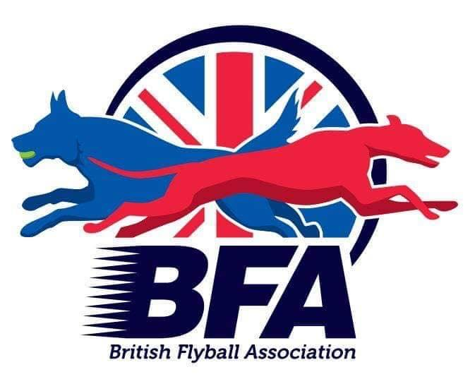
The British Flyball Association

Presents the
British Flyball Association
2024 INDOOR MALVERN EVENT
LIMITED OPEN SANCTIONED TOURNAMENT (60 Teams)

16th to 17th March 2023
(Closing date for entries 12th September 2023)
To be held at
Three Counties Showground, WR13 6NW

Electronic Entries (please note emailed entries will not be accepted):
https://forms.gle/ZzyXqQWeGGEhPCFM7

Please send any queries to: secretary@bfa.email

Payment should be made via BACs to:

The British Flyball Association
Lloyds Bank
30-93-45
00417549

