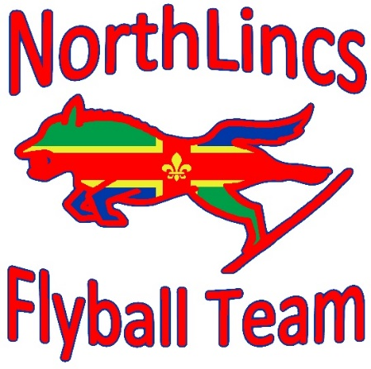
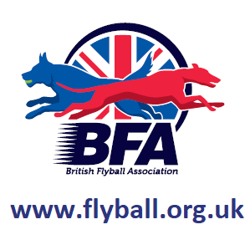


NorthLincs Flyball Team present
Cleethorpes
British Flyball Association Sanctioned Limited
open tournament
(48 teams)
Meridian Showground
Kings Road, Cleethorpes,
North East Lincolnshire, DN35 0AR
over two days on
Saturday 14th September 2024
And Sunday 15st September 2024
(Closing date 14th August 2024)
The event is block format on grass
An information pack will be released closer to the event
For further information, please contact the tournament organiser on
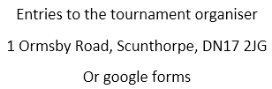
07802677901

NorthLincsFlyball@gmail.com

Show Rules and Regulations

1) The Event Organizer(s) reserve the right to refuse entries and admission to the event of any persons not in good standing within the BFA.

2) No person shall carry out punitive or harsh handling of a dog at the event.

3) Bitches in season are not allowed near the show area. Mating of dogs is not allowed.

4) A dog must be withdrawn from competition if it is:

i) Suffering from infectious or contagious diseases.

ii) A danger to the safety of any person or animal.

iii) Likely to cause suffering to the dog if it continues to compete.

5) It is the Teams Captain’s responsibility to ensure the team is available for their division and running order.

6) The organizer(s) reserve the right to make any alterations they deem necessary in the event of unforeseen circumstances.

7) All dogs enter the event at their own risk and whilst every care will be taken, the Event Organizer(s) cannot accept responsibility for damage, injury, or loss however caused to dogs, persons or property whilst at the event.

8) All owners/handlers must clear up after their dogs. Anyone failing to do so will be asked to leave the venue.

9) BFA Rules and Policies will apply throughout the Sanctioned Tournament

10) If circumstances make it necessary to cancel the tournament, the organisers reserve the right to defray expenses incurred by deducting such expenses from the entry fees received

Please be aware of the following rules that apply to this venue;

11) All competitors MUST obey any “out of bounds” or restricted areas that are in place on the show field.

12) Two entrance gates will be used for the tournament, the main entrance and one at the rear facing the dunes & beach. The rear gate will be locked with a combination lock and the main gate will have stewards to direct to camping etc.

13) All traffic must use the main gate

14) There are electrical cables buried at the minimum legal depth of 750mm in the marked areas. Please avoid using long fence pins/pegs within these areas

15) Electric generators are not allowed on the showground (NE Lincs council rules, not ours)

Payment for open teams is required at the time of entry for the entry to be valid. If we are oversubscribed at the 24 hour stage, only valid entries will be included in the draw. Once numbers are known then foundation teams will be added. In the event of too many foundation entries a draw will be held. Payment for foundation is required within seven days of notification of successful entry.

Payment either by cheque with entry or by bank transfer. Cheques Payable to NorthLincs Flyball Team.

Sort Code: 30-98-97

Account Number: 79447663

Reference for your transfer is your team name

Declared times must be submitted, in writing or email at least 14 days before the tournament and must be at least ½ a second slower or ½ second faster than seed time (BFA rule A1: 4.3)

Team Break Out Time is 0.25 of a second faster than declared time (BFA rule A3: 11)

All times, seed or declared, except Division 1, are subject to the division breakout rule.

Entry via google forms preferred https://forms.gle/3S8hMFmHBd2mQyAE7

Open team entry
 | Open Team Name (£50 per team) | TRN

1

2

3

4

5

6
 | Total

Foundation Team Entry

Foundation Team Name (£8 per dog, max £32)

1

2

3

4

5

6

Total

Camping
Please be aware generators are not allowed on the showground. There are a number of electric hook ups available but we may not be able to site you with your team (we will try, let us know if this is an issue)
 | No. of units | Total

Friday & Saturday camping @ £15

Sunday camping @ £15

No. of electric hook ups at @ £25 extra per connection for the weekend

Total

Captains’ details
Team Captain name
Address
Tel. No.
Email

Please name any members wanting to Judge or measure and if PJ, QJ, HJ, PMO

Please let us know of any accessibility concerns any of your members may have

