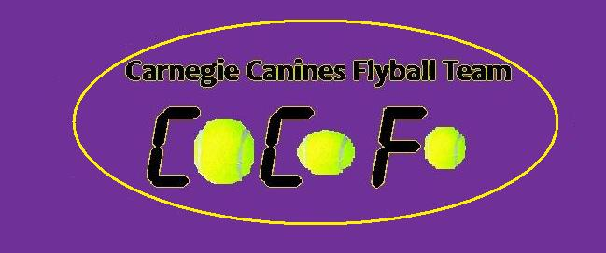

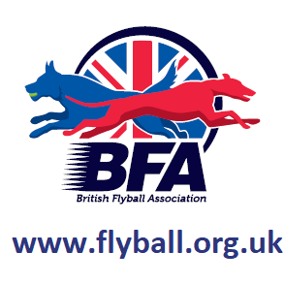
Sanctioned
Limited Open Tournament
30 Teams
Sunday 23rd June 2019
(Closing Date: 24th May 2019)

LochOre Meadows
Crosshill,
Lochgelly Fife
KY5 8BA

Entries to: Michelle Atkinson
92 Menteith Drive, Dunfermline Fife
KY11 8RS
Tel: 07522 922702
Email: matkinson694@googlemail.com

PLEASE BE AWARE THERE IS SWANS AT THIS VENUE

Show Rules and Regulations
- (1) The Event Organiser(s) reserve the right to refuse entries and admission to the event of any persons not in good standing within the BFA.
- (2) No person shall carry out punitive or harsh handling of a dog at the event.
- (3) Bitches in season are not allowed near the show area. Mating of dogs is not allowed.
- (4) A dog must be withdrawn from competition if it is:
- (a) Suffering from infectious or contagious diseases.
- (b) A danger to the safety of any person or animal.
- (c) Likely to cause suffering to the dog if it continues to compete.
- (5) It is the Teams Captain’s responsibility to ensure the team is available for their division and running order.
- (6) The organiser(s) reserve the right to make any alterations they deem
- necessary in the event of unforeseen circumstances.
- (7) All dogs enter the event at their own risk and whilst every care will be taken, the Event Organiser(s) cannot accept responsibility for damage, injury,or loss however caused to dogs, persons or property whilst at the event.
- (8) All owners/handlers must clear up after their dogs. Anyone failing to do so will be asked to leave the venue.
- (9) BFA Rules and Policies will apply throughout the Sanctioned Tournament.
- (10) In the event of a 3 way tie winner will be decided on times. In a 2 way tie the winner is who beat who.
- (11)This is an OUTDOOR tournament, In the event of the tournament being cancelled, the organisers reserve the right to defray expenses incurred by deducting such expenses from the entry fees received
- Further information or queries please contact:
- Michelle Atkinson
- Tel: 07522 922702
- Email: matkinson694@googlemail.com
- There will be catering onsite.

Sunday 23rd June 2019

- Entry Fee-Open £40 per Team
Starters £25 per Team
- 14 days before the Tournament and must be at least 1/2 second slower than seed time. (BFA rule 4.5)
- Team break-out time is half a second faster than declared time (5.17(l))
- All times, seed or declared, except Div 1, are subject to the division break-out rule.

- TEAM NAME BFA No.
- 1
- 2:
- 3:
- 4:
- 5:
- 6:
- Starters Team Name(s)

Team Captain :
- BFA No:
- Address :
- Telephone :
- Email :

- Name of anyone who is a Head Judge, Qualified Judge, Provisional Judge, Qualified Measurer
- or Provisional Measurer (HJ, QJ, PJ, QM, PM):

- Number of teams entered.......................at £45 per team
- Starters Teams………………….at £25 per team
- Total £...................
Cheques payable to Carnegie Canines
- Carnegie Canines Acc No: 11900764
- Sort code: 80-22-60

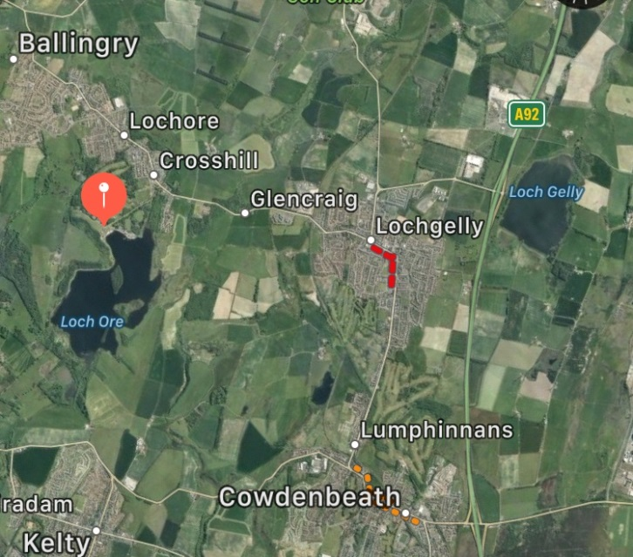

Directions
From North

Join A92 at Dundee. Head south on A92, leave A92 at Lochgelly Junction. Turn Right at the roundabout, 2nd exit at the next roundabout on the B9149. At the third roundabout 2nd exit continuing on the B9149. At the fourth roundabout turn left onto the B981. At the next roundabout turn right onto B920, continue on this road past Lochgelly High School then past Fife Cycle Park, At the next roundabout turn left into LochOre Meadows.

From South
Crossing Forth Road Bridge leave M90 at jct3 onto A92. Take the second exit signposted Lochgelly. Turn Left, , 2nd exit at the roundabout on the B9149. At the second roundabout 2nd exit continuing on the B9149. At the third roundabout turn left onto the B981. At the next roundabout turn right onto B920, continue on this road past Lochgelly High School then past Fife Cycle Park, At the next roundabout turn left into LochOre Meadows.

