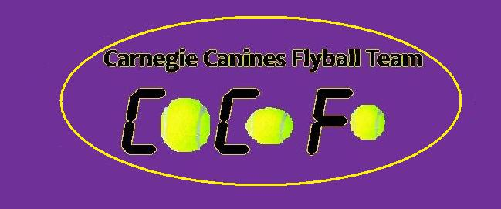

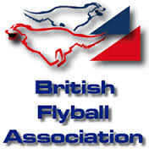
Sanctioned
Limited Open Tournament
Sunday 19th November 2017
(Closing Date: 19th October 2017)

Unit 3
Thistle Industrial Estate
Cowdenbeath
KY4 8LP

Entries to: Michelle Atkinson
92 Menteith Drive, Dunfermline Fife
KY11 8RS
Tel: 07522 922702
Email: matkinson694@googlemail.com

- Show Rules and Regulations
- (1) The Event Organiser(s) reserve the right to refuse entries and admission to the event of any persons not in good standing within the BFA.
- (2) No person shall carry out punitive or harsh handling of a dog at the event.
- (3) Bitches in season are not allowed near the show area. Mating of dogs is not allowed.
- (4) A dog must be withdrawn from competition if it is:
- (a) Suffering from infectious or contagious diseases.
- (b) A danger to the safety of any person or animal.
- (c) Likely to cause suffering to the dog if it continues to compete.
- (5) It is the Teams Captain’s responsibility to ensure the team is available for their division and running order.
- (6) The organiser(s) reserve the right to make any alterations they deem
- necessary in the event of unforeseen circumstances.
- (7) All dogs enter the event at their own risk and whilst every care will be taken, the Event Organiser(s) cannot accept responsibility for damage, injury,or loss however caused to dogs, persons or property whilst at the event.
- (8) All owners/handlers must clear up after their dogs. Anyone failing to do so will be asked to leave the venue.
- (9) BFA Rules and Policies will apply throughout the Sanctioned Tournament.
- (10) In the event of a 3 way tie winner will be decided on times. In a 2 way tie the winner is who beat who.
- (11)This is an INDOOR tournament, In the event of the tournament being cancelled, the organisers reserve the right to defray expenses incurred by deducting such expenses from the entry fees received
- THE TOURNAMENT WILL BE RUN ON 3G ASTRO TURF LAYED ON TOP OF 12MM CRUMB MATTING
- Further information or queries please contact:
- Michelle Atkinson
- Tel: 07522 922702
- Email: matkinson694@googlemail.com
- There will be catering onsite.

Sunday 19th November 2017

- Entry Fee-Open £40 per Team
Starters £25 per Team
- 14 days before the Tournament and must be at least 1/2 second slower than seed time. (BFA rule 4.5)
- Team break-out time is half a second faster than declared time (5.17(l))
- All times, seed or declared, except Div 1, are subject to the division break-out rule.

- TEAM NAME BFA No.
- 1
- 2:
- 3:
- 4:
- 5:
- 6:
- 7:

- Team Captain :
- Address :
- Telephone :
- Email :

- Name of anyone who is a Head Judge, Qualified Judge, Provisional Judge, Qualified Measurer
- or Provisional Measurer (HJ, QJ, PJ, QM, PM):

- Number of teams entered.......................at £40 per team
- Starters Teams………………….at £25 per team
- Total £...................

- Cheques payable to Carnegie Canines

We have indoor parking, Could please try provide us with an appox amount of vehicles will be with your team(s)

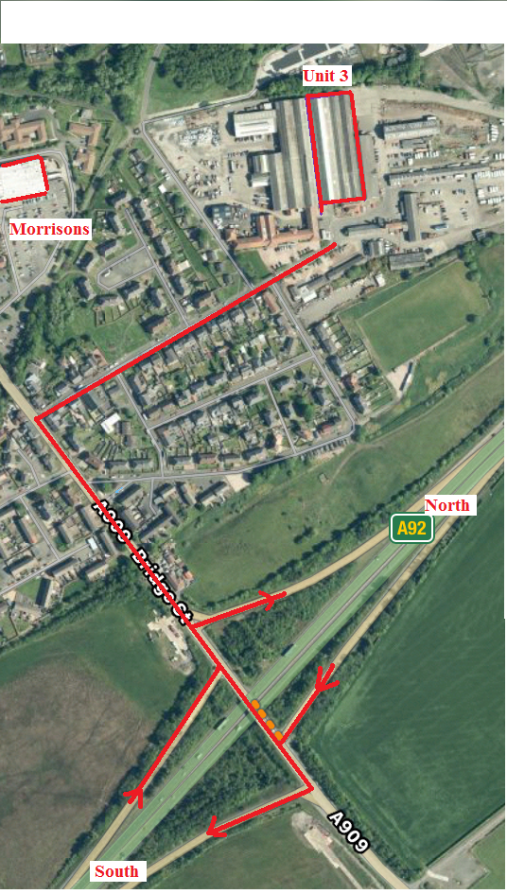

Directions
From North

Join A92 at Dundee. Head south on A92, leave A92 at Cowdenbeath Junction. Turn Right then 100yards take 3rd right onto Church Street. Drive straight down through security gates over double speed bumps. Unit 3 is right in front of you as road bends left. (Big Roller Shutter Door)

From South

Crossing Forth Road Bridge leave M90 at jct3 onto A92. Take the first exit signposted Cowdenbeath. Turn Left then take 3rd right onto Church Street. Drive straight down through security gates over double speed bumps. Unit 3 is right in front of you as road bends left. (Big Roller Shutter Door)

