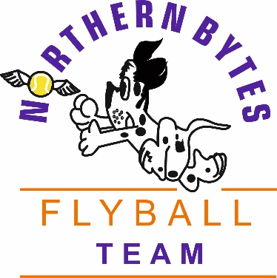
 | invite you to their  BFA Sanctioned
Limited Open Tournament
(48 teams)
Closing date for entries 9th May 2018

to be held at
Littleborough RU Sports Club
Rakewood Road
Littleborough
OL15 0AP
9th & 10th June 2018 – Limited Open
(RR Block Format)
(Closing date Wednesday 9th May 2018)

Please note: No entries can be accepted
without payment
Contact for further Information:
Gordon Fotheringham
2 Far Hey Head Farm, Calderbrook Road, Littleborough OL15 9NS
Telephone: 07521 311553
Email: gordon-foth@hotmail.co.uk
Show Rules and Regulations |  | 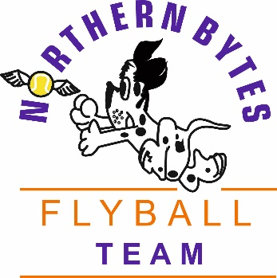
- The tournament organiser(s) reserve the right to refuse entries and admission to any persons not in good standing with the BFA

- No person shall carry out punitive or harsh handling of a dog at the tournament

- Bitches in season are not allowed near the show area. Mating of dogs is not allowed

- A dog must be withdrawn from the tournament if it is:
- Suffering from an infectious or contagious disease
- A danger to the safety of any person or animal
- Likely to cause suffering to the dog if it continues to compete

- It is the Team Captain’s responsibility to ensure the Team is available for their division and running order

- The organiser(s) reserve the right to make any alterations they deem necessary in the event of unforeseen circumstances

- All dogs enter in the tournament at their own risk and whilst every care will be taken, the tournament organiser(s) cannot accept responsibility for damage, injury, or loss however caused to dogs, persons or property whilst at the event.

- All owners/handlers must clean up after their dogs. Anyone failing to do so will be asked to leave the venue

- BFA rules and policies will apply throughout the sanctioned tournament.

- No Alcohol to be consumed within or around the ring.

- All competitors MUST obey any “out of bounds” or restricted areas that are in place on the show field.

- All competitors and visitors are responsible for their dogs and must make every effort to ensure they do not cause noise nuisance when not racing (or waiting to race) to the homes surrounding the show field.

Contact For Further Information

Gordon Fotheringham
2 Far Hey Head Farm, Calderbrook Road, Littleborough OL15 9NS
Telephone: 07521 311553
Email: gordon-foth@hotmail.co.uk

Directions to Venue:-

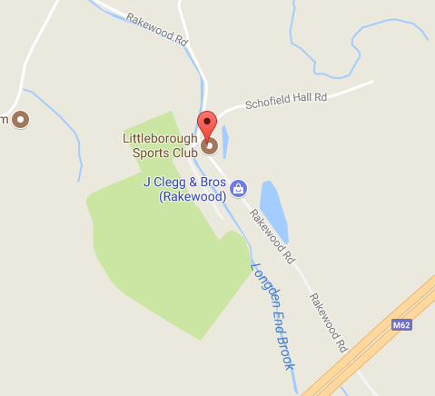 | From the East: Leave the M62 at Junction 21 and turn right (2nd exit) at the first roundabout. Then follow directions below.  From the West: Leave the M62 at Junction 21 and keep right (2nd exit) at the first roundabout, and left (1st exit) at the second roundabout. Then follow directions below.  Then from both directions:  Turn left at the next roundabout, towards the A640 following signs for Milnrow.  When you pass the Aldi (on the left) turn right at the next set of traffic lights onto Bridge Street B6225.  Immediately take the first left at the small roundabout and then bear left at the top of the hill, following signs for Hollingworth Lake.  At the end of the road turn right at the mini roundabout (Smithy Bridge Road).  Follow the road round, keeping the lake on your right hand side, and bearing right in front of the ‘Wine Press’ Restaurant / Public House.  Keep following the road for ½ mile (sign-posted Rakewood) and Littleborough RUFC is located on the right hand side.  No arrivals before 13:00 on Friday please.

Contact For Further Information

Gordon Fotheringham
2 Far Hey Head Farm, Calderbrook Road, Littleborough OL15 9NS
Telephone: 07521 311553
Email: gordon-foth@hotmail.co.uk

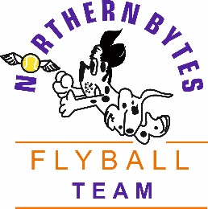 | Entry Form  Littleborough RU Sports Club  Rakewood Road, Littleborough  OL15 0AP
Limited Open Sanctioned Flyball Tournament
on
Saturday 9th June and Sunday 10th June 2018
(Closing date Wednesday 9th May 2018)

Declared times must be submitted in writing (or email) at least 14 days before the tournament and must be at least a half second slower or faster than seeded time and are subject to the team break out rule – (BFA Rule A1. 4.3)
N.B. Team break-out time is half a second faster than declared time. (A1. 4.3)
All times, seed or declared, except Div 1, are subject to the division break-out rule.

Team Name/s |  |  |  |  |  |  | BFA  Team number
1.
2.
3.
4.
5.
6.
Team Captain
Name |  |  |  | Address
Telephone number
email
Financial
Team Entry @ £40.00 per team (Open)….. No. of Teams ……………..  Team Entry @ £25.00 per team (Starters)….. No. of Teams …………….. |  |  |  |  |  |  |  | £  £
Camping @ £8.00 per night per unit |  |  | Friday |  | Saturday
Number of units per night |  |  |  |  |  |  |  | £
Total Cheque Made payable to Northern Bytes |  |  |  |  |  |  |  | £
No entries accepted without payment.
Please complete and return to: Gordon Fotheringham, Email: gordon-foth@hotmail.co.uk or Address: 2 Far Hey Head Farm, Calderbrook Road, Littleborough OL15 9NS Telephone: 07521 311553
NB: Running Orders/Final Details will be published on the BFA Website

Starter Entry Form
Littleborough RU Sports Club
Rakewood Road, Littleborough

OL15 0AP
Starter Competition
on
Saturday 9th June and Sunday 10th June 2018
(Closing date Wednesday 9th May 2018)

Starter Team Name/s |  |  | Estimated Speed
1.
2.
3.
4.
5.
6.
Team Captain
Name |  | Address
Telephone number
email

Available Judges Names …………………………………………………………………………………………

