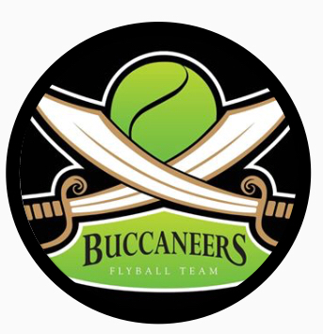

The Buccaneers Flyball Team invite you to a
BFA LIMITED OPEN SANCTIONED TOURNAMENT
Limited 42 teams
On 11th & 12th April 2026

Closing date for entries 24th February 2026
To be held at
Newbury Showground
Priors Court,
Hermitage,
Thatcham,
Berkshire,
RG18 9QZ

Unfortunately the show organizers have notified us of a fee for day trippers, £5 per car, this is not our decision!

PLEASE NOTE: No entries can be accepted without payment. If no payment is received, then entries will be put on the reserve list with paying entries taking precedent.
Electronic entries accepted.

Please note this is just a general booking form.

For further information contact:
Poppy Blake
Address: 22 Wool Grove, Andover, Hampshire, SP10 2QE
Mobile: 07967729486
Email: poppy@scalestowhiskers.com

Team Name/s | BFA Team Number
1
2
3
4
5
6

Qualified/Provisional Judges available: | Measuring Officials/Provisional available: | Regional Rep available:

Declared times must be submitted in writing (or email) at least 14 days before the tournament and must be at least 0.25 a second faster or slower than seed time.
All times, seed or declared, except Div 1, are subject to the Division break-out rule.

Team Captain:
Telephone:
E-Mail:
Address:

Camping number | Number of pitches | £45
Friday
Saturday
 |  | Total £

Team Entry @ £50 per Team
Total made payable to:
Payment by BACS to:
Sort Code:
Account Number:
Use team name as the reference

Please complete and return to:
Poppy Blake
22 Wool Grove
Andover
Hampshire
SP10 2QE
Online Entries Accepted – Email: poppy@scalestowhiskers.com

Show Rules and Regulations

* Event organiser(s) reserve the right to refuse entries and admission to the event of any persons not in good standing with the BFA.
*No person shall carry out punitive or harsh handling of a dog at the event.
*Bitches in season are not allowed near the ring area.
*Mating of dogs is not allowed.
*A dog must be withdrawn from competition if it is:
Suffering from infectious or contagious diseases.
A danger to the safety of any person or animal.
Likely to cause suffering to the dog if it continues to compete.
*It is the Team Captains responsibility to ensure the team is available for their division and running order.
*The organiser(s) reserve the right to make any alterations they deem necessary in the event of unforeseen circumstances.
*All dogs are entered in the event at their owner’s risk and whilst every care will be taken, the event organiser(s) cannot accept responsibility for damage,
injury or loss, however caused, to dog's, persons or property whilst at the event.
*No alcohol is to be consumed within the ring.
*Smoking including vaping/electronic cigarettes is not permitted in or within 10 feet of the flyball ring during competitions.
*All owners/handlers must clean up after their dogs. Anyone failing to do so, will be asked to leave the venue.
*BFA rules and policies will apply throughout the sanctioned tournament.
*If circumstances make it necessary for a tournament to be cancelled, the organiser(s) reserve the right to defray expenses incurred by deducting such expenses from the entry fees received.
*The “two-minute rule” 5.15(a) will apply throughout the tournament.
*There will be “Zero” tolerance of abusive or foul language inside the ring to either ring party, judges & other team members.

