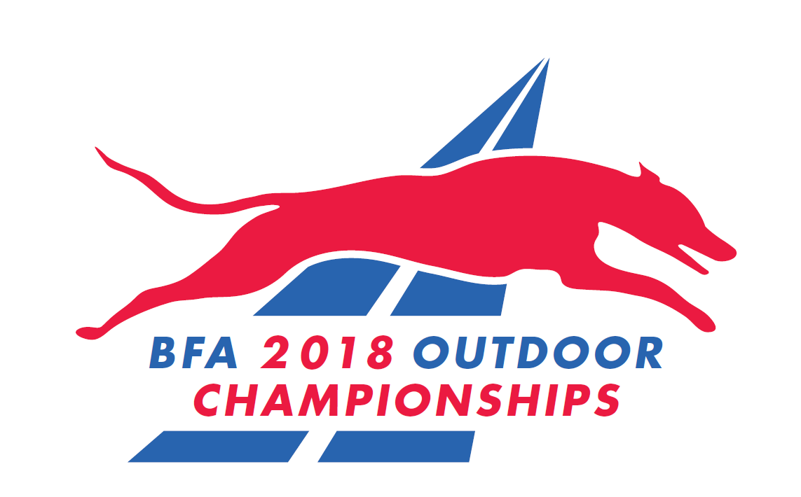

The British Flyball Association

Presents the

British Flyball Association
2018 Championships
LIMITED OPEN SANCTIONED TOURNAMENT
(336 Teams)

Top 18 seeded teams will be entered for Speed Trials and then re-seeded into 3 divisions to be run as Double-Elimination on a different day.

17th, 18th & 19th August 2018

(Closing date for entries 17th July 2018)
To be held at
Catton Hall, Derbyshire, DE12 8LN

Postal entries to:
Katie Burns, 35 Stamford Close, Macclesfield, Cheshire,SK11 7TZ

Electronic Entries (please note emailed entries will not be accepted):
https://docs.google.com/forms/d/e/1FAIpQLSeAJWev-RNeS_hdhFjpoBXiq4hNFbXdqjCafX58n_KV5lERYw/viewform

For any queries: bfachamps2018@gmail.com
PLEASE NOTE:
1. Postal entries will NOT be accepted without accompanying payment by cheque or postal order.

2. Electronic entries MUST be paid within 7 days of notification of successful entry - payment instructions will be sent by email.

British Flyball Association Championships
LIMITED OPEN SANCTIONED TOURNAMENT

Catton Hall, Derbyshire, DE12 8LN on 17th, 18th & 19th August 2018
closing date for entries 17th July 2018
Seed time (Rule A.1.4.13) only BFA Registered Teams with a valid seed time can compete at a BFA Committee organised Sanctioned Tournament (e.g. Championships). There shall be no declared times permitted at a Championship. All seed times, except Div 1, are subject to the Division break-out rule.

Team Details

Team Name(s) | BFA Team Number
1
2
3
4
5
6
7
8
Team Captain

Name: | Address:
Phone Number: | Address:
E-Mail Address:

Electronic entries MUST include an email address.

Financial (No postal entries accepted without payment)

 | Price (Incl Vat) | Number | Cost
Open teams entered... | £50/team
Camping Units... Please complete the camping form on the next page. All camping is subject to availability and must be pre-booked by the closing date (17thJuly 2018) | £36/unit
Total £ (cheques payable to British Flyball Association)
Payment instructions for electronic entries will be sent by email. Payment required within 7 days

Wildcard application -To apply for Wildcard entry to the Championship Teams must have competed at least twice outdoors and hold a current seed time. (See above rule A.1.4.14):
The Committee will consider applications based on the criteria set out below; each application will be considered on its own merits and an explanation is required as to the reasons for the application. Please note Wildcards are limited and there is no guarantee that all wildcard requests will be granted.

- Team is based in an area of development, Isle of Man, Northern Ireland, Wales, Cornwall and Devon, where opportunities for competition are limited by travel distances.
2. Team has been unable to gain entry to enough tournaments to qualify or there have been insufficient tournaments in their region to enable qualification this year.
3. Team has been prevented from meeting qualification criteria due to circumstances beyond their control, despite best efforts made to meet them

Team Name | BFA Team Number | Reason for Wildcard

Reason for application:

_______________________________________________________________________________________________________________________________________________________________________________________________________________________________________________________________________________________________________________________________________________________________________________________________________________

Request for 'Crew' assistance will be available once entry of the teams to the Championship has been confirmed.

British Flyball Association Championships

LIMITED OPEN SANCTIONED TOURNAMENT

Catton Hall, Derbyshire, DE12 8LN on 17th, 18th & 19thAugust 2018

Closing date for entries 17th July 2018

CAMPING FORM
Camping @ £36 per unit for the tournament (1pm Thurs – 10:00am Mon)

There will be two camping fields. The Main camping field will have 650 reserved camping pitches, which will be allocated by team in advance on a strictly first-come-first- served basis.
When this is fully allocated, teams will be allocated to the Extension camping field.

Please Note the Extension camping field is on the other side of the road from the flyball rings and there will be a designated crossing point for pedestrians only.

Please indicate if you would prefer to be allocated in the Extension camping field.

Team Name :
Primary TRN:

Number of camping units required

Camping is strictly limited to current BFA members. Please tick the box to confirm that all campers are current BFA members

Details of assisted / disabled requirements
(Only if this is required)

_______________________________________________________________________________________________________________________________________________________________________________________________________________________________________________________________________________________________________________________________________________________________________________________________________________

INFORMATION ABOUT THE FORMAT

As last year, the competition for the title of British Flyball Champions will be open to the top 18-seeded teams that have entered, rather than just the top 6 as in previous years.
Speed Trials will be run to determine the seeding for the top 3 divisions from these 18 teams.

The Speed Trials, which will be held on Friday will give each team a minimum of 9 runs in order to record the fastest time it can. This will be arranged as a minimum of 3 races per team, and each race will be 3 heats. Each team must attempt to run 4 dogs in each heat.

Speed Trial racing is all about the time - it is not about winning or losing races. Expect exciting racing as teams battle to get into the highest division they can, with the best seeding they can manage. There may be lights as teams try to squeeze the last few 100ths of a second off their time.

These dogs are then rested in preparation for the Double-Elimination divisions two days later.

Double-Elimination differs from a simple knock-out competition in that a team needs to be beaten twice before being eliminated, rather than just once. Teams that have lost one race are raced against each other in the Elimination Bracket for the chance of a place in the final.

In the Double-Elimination, the top two seeded teams in each division get a bye in the first round, and they each race the winner of one of the first-round races. When a team loses its first race, it drops into the Elimination Bracket, where it next races a team that has also lost one race.

When a team in the Elimination Bracket loses a race, this will be its second loss, so it is now out of the competition and is awarded its place in the division.

The Division Final is where the last unbeaten team races against the last team standing in the Elimination Bracket. If the unbeaten team wins, it is the Division Winner.

If it loses, then there is a return final as both teams have now lost a single race.

Double Elimination racing is extremely exciting, as each race is significant to the final result of the division. The division winner - and so the Champions will not be known until the last race

NOTE: All other divisions will be run as Round Robin format

SHOW RULES AND REGULATIONS

  - The tournament organiser(s) reserve the right to refuse entries and admission to any person not in good standing with the B.F.A.
  - No person shall carry out punitive or harsh handling of a dog at the tournament.
  - It is the Team Captains responsibility to ensure the Team is available for its class and running order.
  - The organiser(s) reserve the right to make any alterations they deem necessary in the event of unforeseen circumstances.
  - Bitches in season are not allowed near the show area. Mating of dogs is not allowed.
  - A dog must be withdrawn from competition if it is:
    - Suffering from any infectious or contagious disease
    - A danger to safety of any person or animal
    - Likely to cause suffering to the dog if it continues to compete
  - All dogs enter into the tournament at their own risk and whilst every care will be taken, the organiser(s) cannot accept responsibility for damage, injury or loss however caused to dogs, persons or property whilst at the event.
  - All owners/handlers must clean up after their dogs. Anyone failing to do so will be asked to leave the venue.
  - BFA rules and policies will apply throughout the sanctioned tournament.
  - No alcohol is to be consumed within or around the ring.
  - If circumstances make it necessary that the tournament is cancelled, the organisers reserve the right to defray expenses incurred by deducting such expenses from entry fees received.
  - On and around the flyball and camping fields a strict speed limit (5 mph) will apply and vehicle movement restrictions will apply throughout the event.

Entries will be taken on date of receipt as for all sanctioned tournaments: Rule A.1.3.6.
For any queries please email: bfachamps2018@gmail.com

A maximum of two minutes warm up will be allowed between races.

The lower divisions will be run on Friday, the middle divisions on Saturday and the higher divisions on Sunday.

Please note that this is a three day tournament, and that you may therefore be racing, ring party or judging on any/all of the three days. Please do not enter if you are unable fulfil your tournament responsibilities on all 3 days as refusal of these responsibilities will jeopardise your entry and any future entries to the BFA Championships.

Please tick to confirm that your team is available all three days

