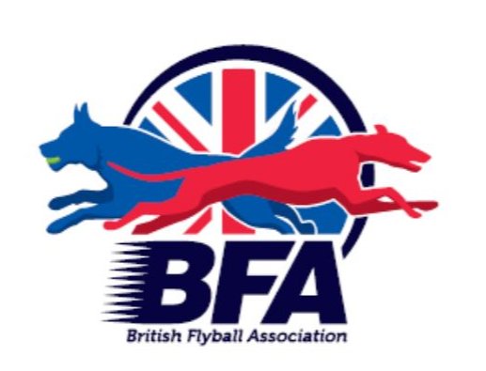

The British Flyball Association

Sponsored by

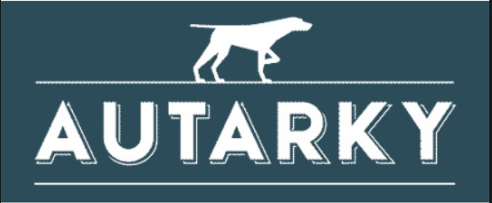

Presents the

British Flyball Association
2022 Championships
INDOOR CHAMPIONSHIPS LIMITED OPEN SANCTIONED TOURNAMENT (100 Teams)

12th to 14th August 2022

(Closing date for entries 12th July 2022)
To be held at
Three Counties Showground, WR13 6NW

OUTDOOR CHAMPIONSHIPS LIMITED OPEN SANCTIONED TOURNAMENT (240 Teams)

18th to 21st August 2022

(Closing date for entries 18th July 2022)
To be held at
Driffield Showground, YO25 9DN

Postal entries to:
Katie Burns, 35 Stamford Close, Macclesfield, Cheshire, SK11 7TZ

Electronic Entries (please note emailed entries will not be accepted):
https://form.jotform.com/221334005742040

For any queries: bfachamps@gmail.com

PLEASE NOTE:
1. Postal entries will NOT be accepted without accompanying payment by cheque
2. Electronic entries - payment instructions will be sent by email.

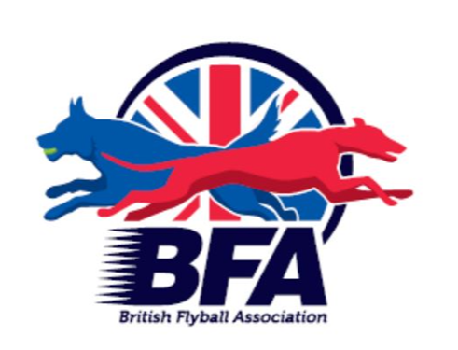

British Flyball Association Championships
LIMITED OPEN SANCTIONED TOURNAMENT

Three Counties Showground 12th to 14th August 2022
Closing date for entries 12th July 2022
Seed time (Rule A.1.4.13) only BFA Registered Teams with a valid seed time can compete at a BFA Committee organised Sanctioned Tournament (e.g. Championships). There shall be no declared times permitted at a Championship (unless in exceptional circumstance and agreed by the Committee). All seed times, except Div 1, are subject to the Division break-out rule.

Team Name(s) | BFA Team Number
1
2
3
4
5
6
7
8
Team Captain

Name: | Address:
Phone Number: | Address:
E-Mail Address:

Electronic entries MUST include an email address.

Financial (No postal entries accepted without payment)

 | Price (Incl Vat) | Number | Cost
Open teams entered | £60/team
Camping Units | £48/unit
Foundation Teams entered | £35/team

British Flyball Association Championships
LIMITED OPEN SANCTIONED TOURNAMENT

Driffield Showground 18th to 21st August 2022
Closing date for entries 18th July 2022
Seed time (Rule A.1.4.13) only BFA Registered Teams with a valid seed time can compete at a BFA Committee organised Sanctioned Tournament (e.g. Championships). There shall be no declared times permitted at a Championship (unless in exceptional circumstance and agreed by the Committee). All seed times, except Div 1, are subject to the Division break-out rule.

Team Name(s) | BFA Team Number
1
2
3
4
5
6
7
8
Team Captain

Name: | Address:
Phone Number: | Address:
E-Mail Address:

Electronic entries MUST include an email address.

Financial (No postal entries accepted without payment)

 | Price (Incl Vat) | Number | Cost
Open teams entered | £60/team
Camping Units | £60/unit
Foundation Teams entered | £35/team

Details of assisted / disabled requirements
(Only if this is required)
____________________________________________________________________________________________________________________________________________________________________________________________________________________________________________________________________________________________________________________________________________________________________________

INFORMATION ABOUT THE FORMAT/SCHEDULE OF EVENTS

Format

The format for the 2022 Flyball Championships will be different to previous championships and this will include all teams taking part in speed trials. This will take place at the beginning of the tournament and following this all teams will then be allocated divisions based on their fastest times.

Each team will race three races of three legs during speed trials and the fastest time will be counted going forward. There will be no break out during speed trials to encourage teams to go as fast as possible. Any dogs wanting to race in the round robin portion of the competition need to run in at least three legs during the speed trials.
Should any team fail to set a time during the speed trials, their time will revert back to their seed time.

Following the speed trials the teams will move onto the round robin portion of the tournament. Each division will have ten teams included and the even seeds will race in a five team round robin and the odd seeds will do likewise. The winners of each half of the division will race in the finals to give an overall champion for each division.

Schedule of events

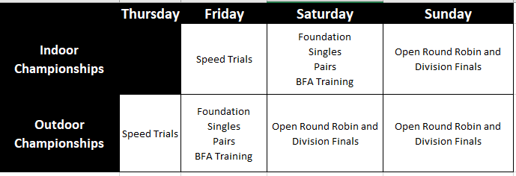

SHOW RULES AND REGULATIONS

  - The tournament organiser(s) reserve the right to refuse entries and admission to any person not in good standing with the B.F.A.
  - No person shall carry out punitive or harsh handling of a dog at the tournament.
  - It is the Team Captains responsibility to ensure the Team is available for its class and running order.
  - The organiser(s) reserve the right to make any alterations they deem necessary in the event of unforeseen circumstances.
  - Bitches in season are not allowed near the show area. Mating of dogs is not allowed.
  - A dog must be withdrawn from competition if it is (please note that no refunds will be issued):
    - Suffering from any infectious or contagious disease
    - A danger to safety of any person or animal
    - Likely to cause suffering to the dog if it continues to compete
  - All dogs enter into the tournament at their own risk and whilst every care will be taken, the organiser(s) cannot accept responsibility for damage, injury or loss however caused to dogs, persons or property whilst at the event.
  - All owners/handlers must clean up after their dogs. Anyone failing to do so will be asked to leave the venue.
  - BFA rules and policies will apply throughout the sanctioned tournament.
  - No alcohol is to be consumed within the ring.
  - If circumstances make it necessary that the tournament is cancelled, the organisers reserve the right to defray expenses incurred by deducting such expenses from entry fees received.
  - On and around the flyball and camping fields a strict speed limit (5 mph) will apply and vehicle movement restrictions will apply throughout the event.

Entries will be taken on date of receipt as for all sanctioned tournaments: Rule A.1.3.6.
For any queries please email: bfachamps@gmail.com

A maximum of two minutes warm up will be allowed between races.

Please note that the indoor championships is a three day tournament and the outdoor championships is a four day tournament, and that you may therefore be racing, ring party or judging on any/all of the days. Please do not enter if you are unable to fulfil your tournament responsibilities on all racing days as refusal of these responsibilities will jeopardise your entry and any future entries to the BFA Championships.

Please tick to confirm that your team is available all racing days

