
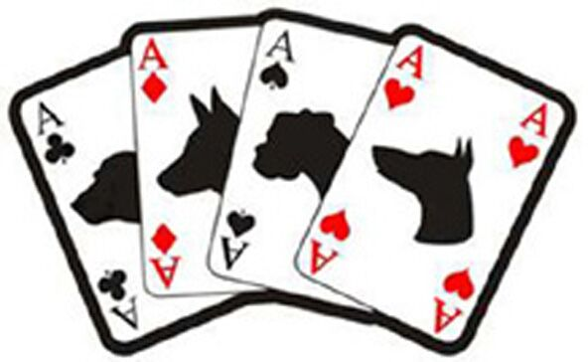

ACES HIGH FLYBALL TEAM
Sponsored by Leipa UK Ltd


Sanctioned Limited Open Tournament (60 Teams)
Staggered Format and run on TuffSpun with a minimum of 60’ Runback

29th & 30th July 2017
Closing 28th June 2017

Ardingly Showground – RH17 6TL
Enter online with iball4flyball, by post or email
Payment must be received within 3 days of entry or entry may be declined.
For Further information, contact: Jeannette Shelley
07845 535194 / jshelley002@gmail.com
Please contact on either of the above for postal address

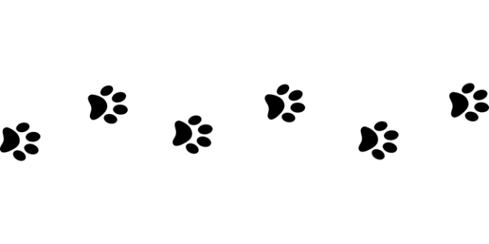

ACES HIGH FLYBALL TEAM
Entry Form
Limited Open Tournament (60 Teams)
29th and 30th July 2017
Declared times must be submitted by email at least 14 days before the tournament and
must be at least half a second faster or slower than seed time. (BFA rule 4.4)
Team breakout time is half a second faster than declared time. All times, seed or
declared, except Division 1, are subject to the division breakout rule. (BFA rule 5.17(I))

 | TEAM NAME | BFA Number | Declared Time
1
2
3
4
5
6
7
8
Team Captain
Email Address
Available Judges

Total Open Teams @ £40 per team £___________________
Total Camping Units @ £10 per night £___________________ Must be booked in advance
Total Payment Due £___________________
Payment is accepted as follows:
PayPal: samv@sky.com (you MUST select Friends & Family option)
BACS: Aces High Flyball Club, Lloyds Bank, Acc Number: 42175868 Sort Code 30-64-57
Apologies but Cheque payments are no longer accepted

ACES HIGH FLYBALL TEAM
Show Rules and Regulations
1. The tournament organiser(s) reserve the right to refuse entries and admission to any person not in good standing with the B.F.A.
2. No person shall carry out punitive or harsh handling of a dog at the tournament.
3. It is the Team Captains responsibility to ensure the Team is available for its class and running order.
4. The organiser(s) reserve the right to make any alterations they deem necessary in the event of unforeseen circumstances.
5. Bitches in season are not allowed near the show area. Mating of dogs is not allowed.
6. A dog must be withdrawn from competition if it is:
a. Suffering from any infectious or contagious disease
b. A danger to safety of any person or animal
c. Likely to cause suffering to the dog if it continues to compete
7. All dogs enter into the tournament at their own risk and whilst every care will be taken, the organiser(s) cannot accept responsibility for damage, injury or loss however caused to dogs, persons or property whilst at the event.
8. All owners/handlers must clean up after their dogs. Anyone failing to do so will be asked to leave the venue.
9. BFA rules and policies will apply throughout the sanctioned tournament.
10. No alcohol is to be consumed within or around the ring.
11. NO BARBEQUES TO BE USED DIRECTLY ON THE GRASS – Scorch marks on the grass will be chargeable
12. Intermediates, if held, will be run based on current BFA rules and guidelines. Jump heights must be set at 7”.
Any Non BFA Members competing in Starters are the responsibility of the Primary Team Captain.
14. If circumstances make it necessary that the tournament is cancelled, the organisers reserve the right to defray expenses incurred by deducting such expenses from entry fees received.
15. No smoking or Vaping in or around the vicinity of the Ring, Administration Areas or any Tournament Information Areas. The organiser considers the immediate area around the Ring/Administration Areas/Tournament Information areas to be a minimum distance of 300 yards in any direction.

